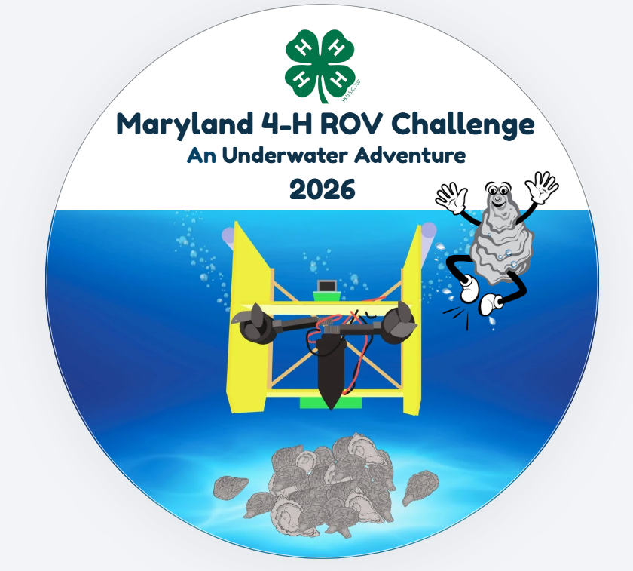

This work is supported by "Transforming Shellfish Farming with Smart Technology and Management Practices for Sustainable Production" grant no. 2020-68012-31805/project accession no. 1023149 from the USDA National Institute of Food and Agriculture. Any opinions, findings, conclusions, or recommendations expressed in this publication are those of the author(s) and do not necessarily reflect the view of the U.S. Department of Agriculture.


University programs, activities, and facilities are available to all without regard to race, color, sex, gender identity or expression, sexual orientation, marital status, age, national origin, political affiliation, physical or mental disability, religion, protected veteran status, genetic information, personal appearance, or any other legally protected class.
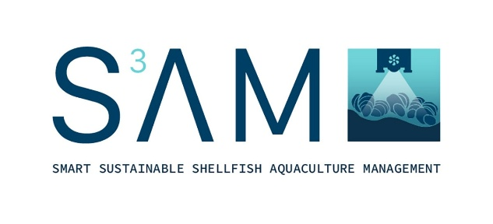

What is S³AM
The Investigating Oysters underwater science activities are part of the Smart, Sustainable Shellfish Aquaculture Management (S³AM) program. S³AM is a nationwide, multi-institutional, USDA-funded project that uses smart technology to increase farming efficiency, economic viability, and environmental sustainability of oyster aquaculture. S³AM is achieving these goals by collaboratively developing and field-testing equipment and software to monitor farmed oyster populations and harvesting technology designed to target market-sized oysters.

These advancements will allow farmers to reduce time and fuel usage and minimize the environmental impacts of traditional harvest methods. Further, the innovations and knowledge generated from this project will be delivered to undergraduate students at minority-serving partner institutions, our Maryland 4-H youth, and oyster farmers on the Atlantic, Gulf, and Pacific coasts.

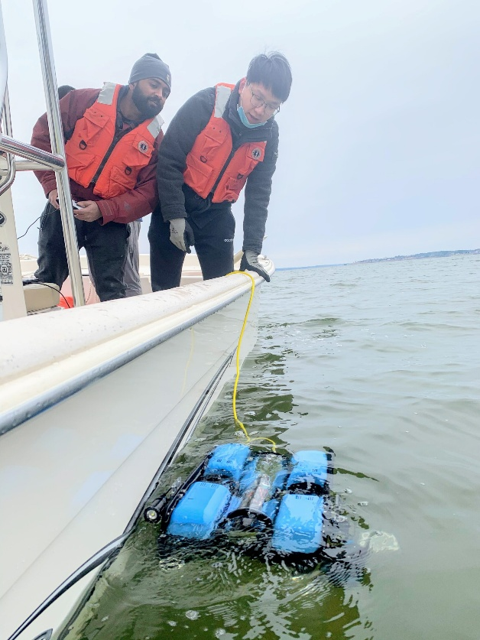
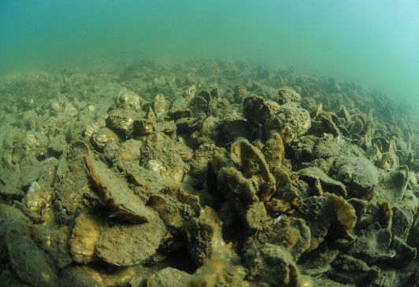
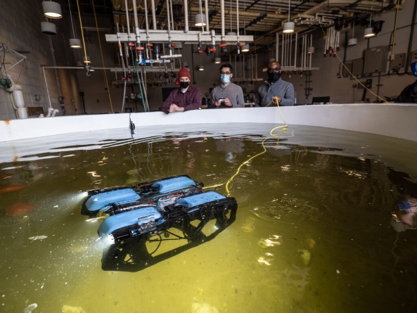
For more information on S³AM: https://s3amoysters.umd.edu/

The Maryland 4-H SAM ROV Challenge
The term ROV stands for “Remotely Operated Vehicle”. Although this term could apply to land, sea or air vehicles, it has been used primarily for tethered underwater vehicles since the early 1960’s.
The SAM ROV Challenge provides 4-H members with an opportunity to learn, build and compete with a simple underwater ROV. The SAM ROV was designed to have simple construction yet accurately represent the key features of a commercial ROV. The 4-H SAM ROV Kit contains everything that is needed to construct the ROV. The Challenge will feature six ROV activities that mimic real life oyster production activities. The teams will also propose a research/engineering design project that is focused on shellfish aquaculture.
If you have any questions about the Challenge, please contact Willie Lantz at wlantz@umd.edu or call 301-334-6960.

Date and Location
The Challenge will be held on Tuesday, August 18th with a back up date of August 25th. The location is to be determined at this time but will likely be in central Maryland.

Teams, Coaches and Registration
- Teams
Teams can consist of 3-8 4-H Members. There are no restrictions on the ages of 4-H members on a team. All team members must be enrolled in 4-H Online by July 1, 2026 (extended till August 1st). Contact your local 4-H County Office to enroll in 4-H. Teams from the same 4-H Club with multiple teams will be asked to have a minimum of 4 members per team.

- Coaches
Each team must have two coaches that are official University of Maryland Extension Volunteers. Coaches must be enrolled in 4-H Online and complete volunteer training and background check by July 15, 2026 (extended until 8/10/2026). Contact your local 4-H County office for more information. If you are unsure about how to contact the local 4-H county office contact the Maryland State 4-H Office at 301-314-9070. Coaches may serve multiple teams at the event.

- Team Registration
The coach from each team should complete the google doc which can be found at ROV Challenge Registration Form or https://forms.gle/ytytJL9tuDqegnwS7.

Teams must be registered no later than June 15, 2026 (extended to 7/20/26). Note this form does not enroll team members or coaches in 4-H Online as that must be done with the county 4-H office. 4-H members and coaches have until the dates indicated above to become official members and volunteers. Only two teams will be allowed to register per county on a first come first serve basis. Teams are highly encouraged to work through the local county office prior to completing the registration form. Once teams are confirmed, they will be notified of their acceptance into the Challenge. Additional teams will be put on a wait list. The competition will also be limited to 32 teams. Once the June 15th deadline has passed, additional teams will be accepted based on when their registration was completed.
The Game
- ROV
The ROV for the game must be made from the official SAM ROV kit obtained from Maryland 4-H. Once you have submitted your Team Registration you will be contacted about an ROV kit. The ROV Competition Kit will consist of 2 ROVs in a pack and one controller pack (which also has a battery).

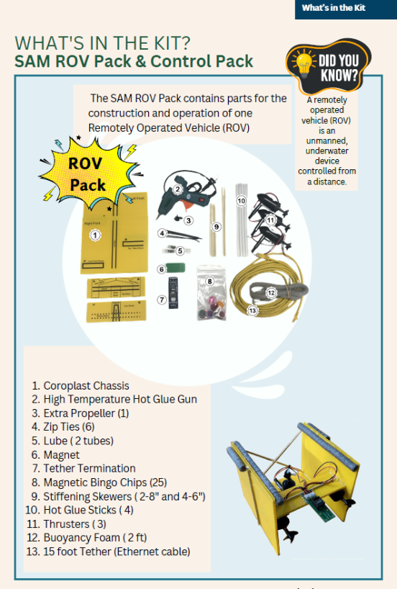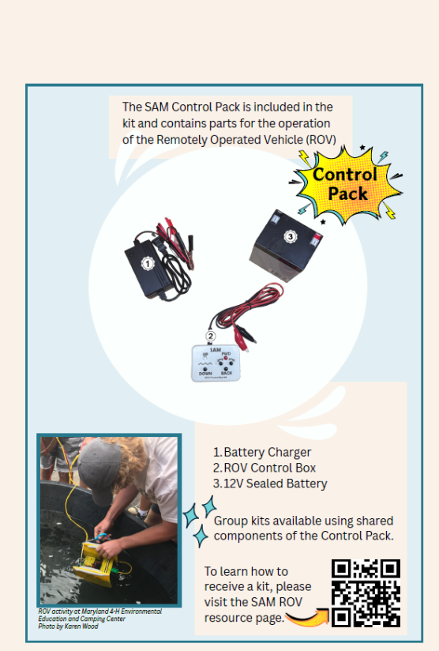

Only certain additional materials are allowed to customize your ROV. These are:
- Popsicle Sticks
- ¼” Dowel rod up to 24” in total length
- Chloroplast up to 3/8” thick and not more than 12 square inches
- Low density foam such as pool noodle material
- String
*These additional components may only be attached to the ROV using hot glue.
*Spare ROV Kit Parts will be available at the event for any needed repairs.
ROV Inspection
Teams may bring two complete ROVs to the competition. Each ROV will be inspected before the competition. ROVs will be inspected for allowable materials and sharp edges that may damage the pool.
A link to a complete set of instructional videos on how to assemble the ROV will be emailed to the coach. Coaches may also request the “Investigating Oysters 4-H Gude to Underwater Science Activities for Youth” curriculum by going to https://extension.umd.edu/resource/investigating-oysters-4-h-guide-underwater-science-activities-youth-ec-2025-0751/. The curriculum will be helpful to learn more about oysters and for the research project. You can also view all the ROV materials at https://www.gearsinc.org/sam/.

- Competition Pool
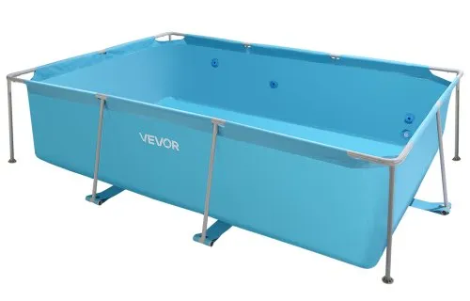
The competition will take place in 2 separate pools, with three activities conducted in each pool. The pools will be approximately 120” long, 78” wide, 30” deep. Pools will be similar to the one pictured below. A table will be provided beside the pool for teams to place their ROV and other materials.

- ROV Operation
Three team members will be allowed at the pool to operate the ROV. The following are the roles of the team members:
- Operator – will handle the controls and drive the ROV. The operator is not to touch the ROV during the match.
- Tether Manager – will feed and coil the ROV tether. Can not pull the ROV back to the surface or manipulate the cable to assist with any mission. A warning will be issued for the first offense of manipulating the robot with the tether. Additional occurrence will result in a 5-point penalty.
- Spotter – Can watch the ROV and report to the Operator. Spotter will also add oysters and collect the oysters from the ROV.
The ROV will start at the designated end of the pool at the surface held by the Spotter. At the announcement of the start of the match the Operator will begin driving the ROV. Each ROV round will last for 6 minutes. At the end of the ROV round the Operator will place the controller immediately on the table.

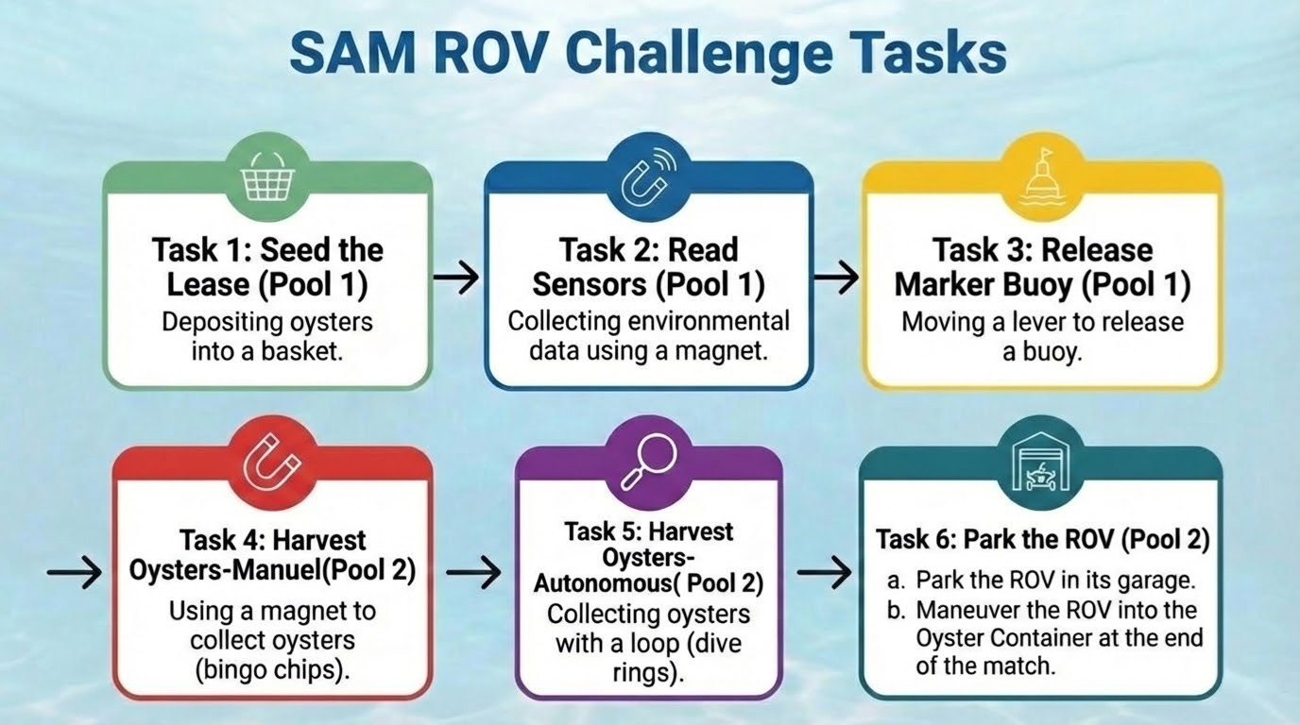
- ROV Missions

*Missions within a pool may be performed in any order
  - Seed the Lease. (pool 1)
  - Deliver Oyster shells with set spat to designated areas
  - Teams will be provided with oyster shells (with circular handles attached).
  - ROV must deposit the shells one at a time in a Designated Area on the bottom.
  - The Designated Area will be a 14” diameter circular container with 3” high raised edges.
  - Oysters weigh approximately xxx grams when submerged.

  - Read Sensors. (pool 1)
- Read underwater sensors to collect environmental data.
- Sensors are “read” by touching the top with a magnet (provided in the ROV kit).
- Sensors will flash when they are read.
- Receive points for each sensor read.
- Sensors will be located at three different levels: 6”, 12” & 18” above bottom.

  - Release marker buoy. (pool 1)
  - Release a floating buoy to mark the oyster lease.
  - Buoys are stored in a vertical tube and are released by removing a top cover.
  - The cover is removed by rotating it 180 degrees horizontally.
  - A 6” length of ½” PVC pipe is attached to the cover to act as a handle. This can be pushed by the ROV to rotate the cover out of the way.
  - Minimal pushing power is required.

  - Harvest Oysters (Manual). (pool 2)
- Collect Oysters off the bottom and return to farmer.
- Oysters are represented by Bingo chips (provided with the ROV kit) which can be collected with a magnet (part of the ROV kit).
- Collect as many Oysters as possible and return to surface
- Receive points for all Oysters placed in collection cup at surface (before match ends).

  - Harvest Oysters (Autonomous). (pool 2)
  - Harvest Oysters and place in Transport container
  - Oysters are represented by dive rings
  - Collect as many Oysters as possible and move them to the designated container underwater.
  - The oysters may not be brought to the surface.
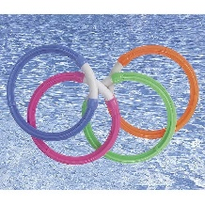
Available at Walmart, Home Depot and Lowes

  - Park the ROV. (pool 2)
- Park the ROV in its garage.
- Maneuver the ROV into the Oyster Container at the end of the match.
Research Proposal
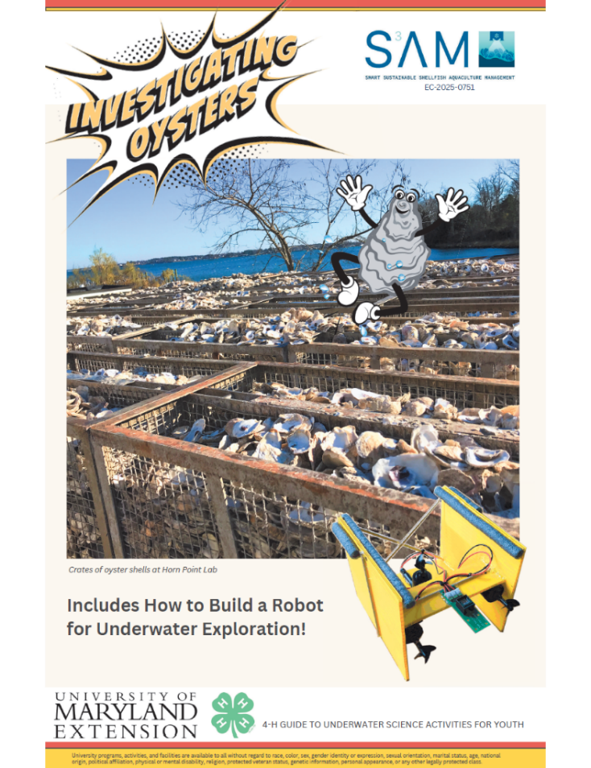
Each team will be required to propose a research project. The team should identify a problem and propose a solution to the problem using either the scientific method or the engineering design process. Thought should be given to the steps that would be taken to complete the research project. The team does not need to complete the research or project design. The team should display their proposals on a trifold display board that is between 28” tall by 40” wide to 36” tall by 48” wide. The team should share their project with a community or science-based group prior to the challenge (info included on the display). A small group of judges will evaluate the display board at a designated time during the competition. Team members should be present to answer questions. Teams may wish to download the “Investigating Oysters 4-H Gude to Underwater Science Activities for Youth” curriculum by going to https://extension.umd.edu/resource/investigating-oysters-4-h-guide-underwater-science-activities-youth-ec-2025-0751/. The curriculum will be helpful to learn more about oysters and oyster production.

