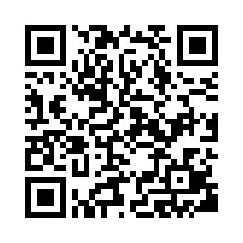
Steps to Use QR Code
- Go to your app store and search for “QR Code Reader”.

- Download and install QR Code Reader. This is a free app.

- Open QR code Reader and center code in the picture/code window. This will take you to the online survey.

Workshop Instructor:
Workshop Topic:

Steps to Use QR Code
- Go to your app store and search for “QR Code Reader”.

- Download and install QR Code Reader. This is a free app.

- Open QR code Reader and center code in the picture/code window. This will take you to the online survey.

Workshop Instructor:
Workshop Topic:

Steps to Use QR Code
- Go to your app store and search for “QR Code Reader”.

- Download and install QR Code Reader. This is a free app.

- Open QR code Reader and center code in the picture/code window. This will take you to the online survey.

Workshop Instructor:
Workshop Topic:

Steps to Use QR Code
- Go to your app store and search for “QR Code Reader”.

- Download and install QR Code Reader. This is a free app.

- Open QR code Reader and center code in the picture/code window. This will take you to the online survey.

Workshop Instructor:
Workshop Topic:

Please Rate my Teaching!

Please Rate my Teaching!

Please Rate my Teaching!

Please Rate my Teaching!

