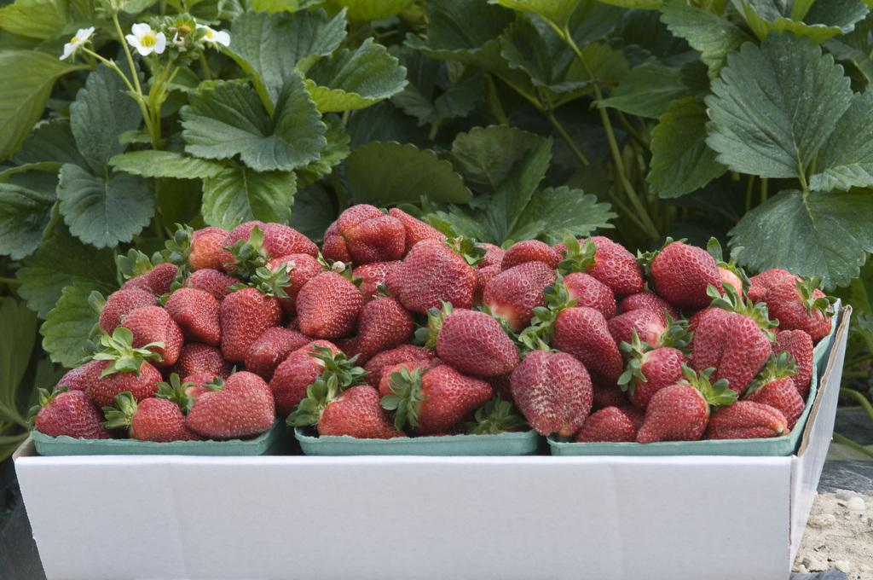

COMMERCIAL HORTICULTURE
Commercial Horticulture in Montgomery County is a growing industry. This area of agriculture includes commercial landscape, nursery, greenhouse, turf and garden center industries, as well as the commercial fruit and vegetable producers.
As a part of the agriculture industry, this segment produces more than $120 million annually and ranks second in the state. Montgomery County is a state leader in nursery and greenhouse production.
Programs are offered in several areas which include:
- Commercial Pesticide training and re-certification
- Nutrient Voucher Training
- Nutrient Management Training for the Landscape Industry
- Business Planning
- Integrated Pest Management
Other informative links:
- Montgomery County Pesticide Law
- Electronic IPM Newsletters
  - Landscape & Nursery
  - Greenhouse & Cut Flower
- Spotted Wing Drosophila Resources from Dr. Kelly Hamby, Extension Entomologist
- 2021 Annual Procrastinator's Conference
- Soil/Manure/Growing Media/Tissue Testing Lab Comparisons

