4-H Small Pet Project

MARYLAND 4-H ANIMAL SCIENCE -
SMALL PET PROJECT RECORD

Name |  | 4-H Age
Primary Club Name
Years in 4-H |  | Years in this Project:
I have completed this record and believe all information to be complete and accurate. (Print and sign/date.)

____________________________ ________________ ___________________________ _______________
Member’s Signature Date Parent’s Signature Date

Please indicate your Animal Science Project Area
 | Cat |  | Gerbil |  | Hamster |  | Snake |  | Other:

What goals did you set for your project this year and how did you achieve them?

What were two things you learned from completing this project this year?

What is one thing you would like to improve or do differently with your project next year?

Life Skills
Describe the Life Skills you used and what you learned in relation to your project.

Example Table
I used one or more of these Life Skills from the Targeting Life Skills Wheel | What I learned as a result of using this skill.
HEAD  Example: Decision Making | I learned that I needed to be sure to budget my money when purchasing my rabbit projects so I would have enough to cover all of my expenses.
HEART  Example: Sharing | I learned how to give younger 4-H members pointers on how to fit and show their animals properly
HAND  Example: Healthy Life Choices | I learned that animals don’t grow well unless they receive the proper food.
HEALTH  Example: Managing Feelings | I learned to control my feelings when I became frustrated that my pig would not cooperate to get loaded on the trailer.

I used one or more of these Life Skills from the Targeting Life Skills Wheel | What I learned as a result of using this skill.
HEAD

HEART

HAND

HEALTH

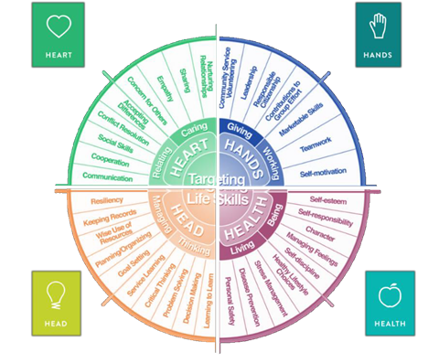

MARYLAND 4-H SMALL PET PROJECT RECORD

Project Activities
Include: Field Trips. Skillathon, Judging, Workshops, Quality Assurance, Class Participation, etc.
All project activities listed should be about this project area only.
Date | Name of Activity/Event | Location  (school, club, county, state, national, etc.)

Project Communications
Include: Speeches, Demonstrations, Visual Presentations, etc.
All project communications listed should be about this project area only.
Date | Type of Communication | Title | Location  (school, club, county, state, national, etc.)

Project Exhibits
Include: Fair, Shows, Community Events, Contests, etc. All project exhibits listed should be for this project area only.
Date | Exhibit/Class | Event/Activity | Placing
Table 1: Small Pet Information
 | Small Pet #1 | Small Pet #2 | Small Pet #3
Name
Breed
Birthdate
Pet’s Age
Male or Female
Spayed or Neutered
Color

Table 2: Write a brief statement about how you obtained your small pet
Pet #1
Pet #2
Pet #3

Table 3: Vaccine Record
Pet’s Name | Vaccine | Date Given | Date Due (Expiration)

Table 4: Health and Veterinary Record and Expenses
Date | Pet’s Name | Reason for Treatment or Veterinary Visit | Treatment | Cost
Total Health and Veterinary Costs
Table 5: Feeding Record and Expenses
Pet’s Name | Type of Food | Amount Fed/Week | Total Cost per Week | Total Cost/Year  (Total Cost Per Week x 52 Weeks)
Total Costs

Table 6: All Other Expenses
Includes: Toys, Training, Treats, etc.
Pet’s Name | Date | Explanation of Items | Cost
Total of All Other Expenses

Table 7: All Income
Includes: Premiums, Selling Offspring, etc.
Date | Description of Income | Income
Total Income

Table 8: Daily Care and Routine
Explain the daily care and routine you follow with your pet(s).
Pet’s Name | Explanation

Financial Summary: Please make sure to use the above totals.
Determine how much money you made or lost on your project animals. You can determine your profit/loss by:
- Income | - Income Total (Table 7) | $
 | Total Income (A) | $
- Expenses | - Health and Veterinary Expenses (Table 4) | $
 | - Feed Expenses (Table 5) | $
 | - All Other Expenses (Table 6) | $
 | Total Expenses (B) | $
- Total | Subtract B from A to get total | $  (Profit or loss)

