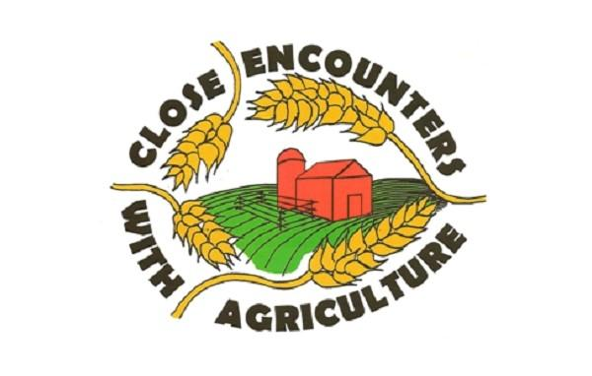

Close Encounters with Agriculture
Close Encounters with Agriculture is an award winning program offered each year to Montgomery County fourth grade students. Since 1993, over 80,000 students have participated in this hands-on educational program designed to teach students about modern agriculture, maintaining a healthy environment and leading a healthy lifestyle.
2021 Close Encounters Fact Sheet
2021 Teacher Materials

Teacher's Notebook
- Agriculture
- Environment
- Nutrition

Learning Station Videos

Agriculture
- Beef
- Dairy
- Goats
- Relay

Environment
- Habitat Relay
- Rainfall
- Soils
- Stream Insects
- Who Polluted the Potomac

Nutrition
- Grains
- Nutrition
- Quiz

Co-Sponsoring Groups
- Montgomery County 4-H, FCE, Master Gardeners, and Farming Community Volunteers
- University of Maryland Extension - Montgomery County Office
- Montgomery County Office of Agriculture
- Montgomery Soil Conservation District
- USDA Natural Resources Conservation Service
- Montgomery County Farm Bureau
- Maryland-National Capital Park and Planning Commission
- Montgomery County Agricultural Center (Fair Board)
- Maryland Grain Producers Utilization Board
- Friends of the Agricultural History Farm Park
- Edward B. Byrd Charitable Foundation

