Maryland 4-H Animal Science – Livestock Market
Project Record
Name |  |  | 4-H Age
Primary Club Name
Years in 4-H |  |  | Years in this Project
I have completed this record and believe all information to be complete and accurate.

Member’s Signature Date Parent’s Signature Date

______________________ ________ ______________________ ________
Leader’s Signature Date Educator’s Signature Date

Please indicate your Animal Science Project Area
☐Beef/Dairy Steer | ☐Market Goat | ☐Market Sheep | ☐Market Swine
What goals did you set for your project this year and did you achieve them?
1.

2.

3.

What were four things you learned from completing this project this year?
1.

2.

3.

4.

What is one thing you would like to improve or do differently with your project next year?
Life Skills
Describe the Life Skills you used and what you learned in relation to your project.
Example Table
I used one or more of these Life Skills from the Targeting Life Skills Wheel | What I learned as a result of using this skill.
HEAD  Example: Decision Making | I learned that I needed to be sure to budget my money when purchasing my rabbit projects so I would have enough to cover all of my expenses.
HEART  Example: Sharing | I learned how to give younger 4-H members pointers on how to fit and show their animals properly.
HAND  Example: Community Service Volunteering | I took my lambs to the elementary schools “Ag Day” and I was able to teach and expose 100 students about my lamb project.
HEALTH  Example: Managing Feelings | I learned to control my feelings when I became frustrated that my pig would not cooperate to get loaded on the trailer

I used one or more of these Life Skills from the Targeting Life Skills Wheel | What I learned as a result of using this skill.
HEAD | 1.  2.
HEART | 1.  2.
HAND | 1.  2.
HEALTH | 1.  2.

The diagram below shows many of the Life Skills learned in 4-H:
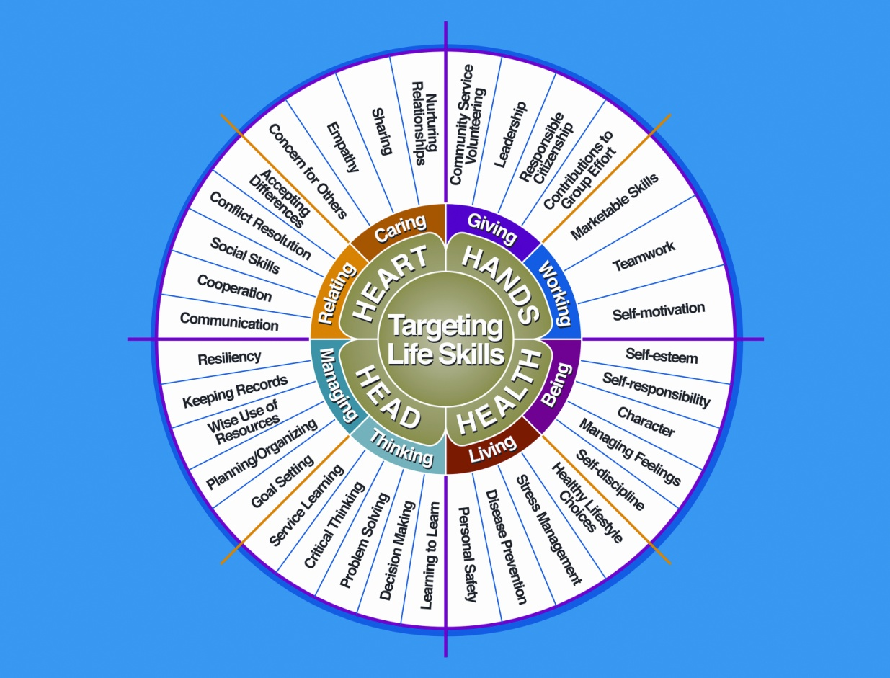

Courtesy of Iowa State University-Used with Permission 11/2012

Project Activities
Include: Field Trips, Skillathon, Judging, Workshops, Quality Assurance, Class Participation, etc.
All project activities listed should be about this project area only.
Date | Name of Activity/Event | Location  (School, Club, County, Regional, State, National etc.)

Project Communications
All project communications listed should be about this project area only.
Date | Type of Communication  (Speech, Demonstration, Visual Presentation, etc.) | Title | Location  (School, Club, County, Regional, State, National etc.)

Project Exhibits
Include: Fairs, Shows, Community Events, etc.
All project exhibits listed should be for projects in this area only.
Date | Exhibit | Location/Event | Placing  (if applicable)

Table 1: Information on Project Animals

Project Animal Description |  |  |  | Beginning of Project |  |  |  | End of Project |  |  |  |  | Final Production
Breed | Sex | Identification  4-H Tag # |  | Weigh-in  Date | Weight | Purchase Cost or  Market Value |  | Weigh-in Date | Weight | Selling  Price or  Market Value | Death, Loss, or Sold Date |  | Days  On  Feed | Lbs.  Gained | Lbs.  Per  Day
TOTALS - -

Lbs Gained Per Day
To calculate lbs. gained take the lbs. gained and divide by the number of days on feed.

Table 2: Feed Expenses
Date Purchased | Type of feed (grain, mix, hay, supplement, pasture, silage) | $/lb (total cost divided by lbs) | Pounds (lbs) | Total Cost
Total pounds and total feed costs

Feed Efficiency
To calculate feed efficiency take the total pounds gained by all of your market animals and divide that by the total pounds of feed you have fed them.

Feed Efficiency = ___________________

Table 3: All Other Expenses
(Bedding, Insurance, Entry Fees, Equipment, Sale Commission, Supplies, Etc.)
Date | Description of Item or Expense | Cost
Total All Other Expenses

Table 4: Health and Veterinary Expenses
List practices & materials used to treat or protect your animals from parasites, illnesses, & diseases. Include veterinary examinations, health papers, treatments for illnesses or injuries, foot care, vaccinations, medications & dewormers etc.
Date(s) Treated | 4-H Tag#/  Animal ID | Reason for Treatment or Veterinary Visit | Treatment Given | Withdrawal Period |  | Cost
 |  |  |  | Days | Date Completed
Total Health and Veterinary Expenses
Table 5: Sale Animal Income
Income from animals sold through 4-H Livestock Sale(s), Privately Sold, Sold at Livestock Auction, etc.
Date Sold | Description of Income  (Include 4-H Tag #) | Final Weight | Gross Sale  (Amount of Check) | $/lb  (net sale/final weight)
Total weight and value of animals sold |  |  |  | N/A

Table 6: All Other Income
Include all other income from project animal(s) including premiums, products (wool, etc.) , etc.
Date | Description of Income | Income $
Total All Other Income

Financial Summary: Please make sure to use the above totals.
Determine how much money you made or lost on your project animals. You can determine your profit (or loss) by:

- Add Income
- Sale Animal Income (Table 5) $ ________
- All Other Income (Table 6) $ ________

Total Income (A) $ ________
- Add Expenses
- Project Animal Costs (Table 1) $ ________
- Feed Expenses (Table 2) $ ________
- All Other Expenses (Table 3) $ ________
- Health and Veterinary Expenses (Table 4) $ ________

Total Expenses (B)$________

Subtract B from A to get profit or loss Total $________ (profit or loss)

University of Maryland Extension programs are open to all persons and will not discriminate against anyone because of race, age, sex, color, sexual orientation, physical or mental disability, religion, ancestry, or national origin, marital status, genetic information, or political affiliation, or gender identity and expression.

3/2013

