General 4-H Project Record
(For each project you worked on, fill out a record if you
would like formal recognition of your project work.)

Click on each field. Then type your information in the box.

To complete a project and qualify for an award pin, you need to do the following things:
(1) learning experiences: participate in several learning experiences that help you learn about the project;
(2) communication event: give a talk or presentation that is related to your project;
(3) exhibit: display your project-related work somewhere in a public place.
Completion of two out of three requirements qualifies you for a project certificate.

Name:

4-H Age:

Name of Project:

Number of years I have worked on this project:

Title of 4-H Project Guide (if you used one):

These were my project goals for the year:
I have completed this record and I believe that all information is complete and accurate.

Member Signature Date

Parent Signature Date

Date | Communication Events  Describe the talks and presentations you have given about this project. | Location | Rating/How did you do?

Date | Exhibits  Describe the public displays, posters, fair entries, and awards related to this project. | Location | Rating/How did you do?

Date | Learning Experiences  Describe the things you have done to learn more about this project: meetings, tours, workshops, club activities, research, etc. | What I Learned
Need more room? Add a page if necessary.
Date | Financial Journal  Income is the money you have received from fair premiums, selling items, etc. for this project. Expenses are the money you have spent related to this project. | Income | Expenses
 |  | Income:
 |  | Expenses:
 |  | Profit (+) or Loss (-):

Resources
You may want to use this space to list or describe the resources you used to learn more about this project. Include books, internet sites, volunteers, parents, other 4-H members, and professionals.

Project Skills
Did you accomplish your project goals this year? Why or why not?

What are the most important things you have learned from this project and/or what are the most important results of your work on this project?

Life Skills

Fill out this section to describe the life skills you used and what you learned in relation to your project. Examples
I used these Life Skills | This is what I learned as a result of using this skill
HEAD  Example: Decision Making | I learned that I needed to be sure to budget my money when purchasing craft supplies so I would  have enough to cover all of my expenses.
HEART  Example: Sharing | I learned how to give younger 4-H members pointers on how to make a wreath through a visual  presentation.
HAND  Example: Community Service Volunteering | Through my woodworking project, I have learned many new skills. I found it to be beneficial to  my community to utilize those woodworking skills when volunteering to build a wheel chair ramp.
HEALTH  Example: Managing Feelings | I learned to control my feelings when I became frustrated that the new cake I baked didn’t rise. Since I didn’t have success with the new cake recipe, I am going to research other options that I could try.

I used these Life Skills This is what I learned as a result of using this skill.
(see the Life Skills Wheel for ideas)
- HEAD :
- HEART:
- HANDS :
- HEALTH :

Life Skills Wheel: The diagram below shows many of the life skills learned in 4-H.
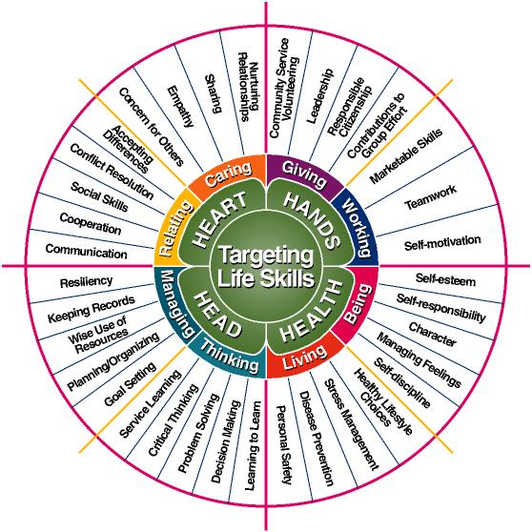
Courtesy of Iowa State University

