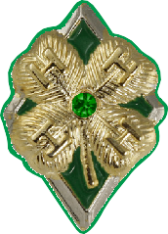Address: Town/State/Zip: 4-H County or Baltimore City: Club(s):
Maryland 4-H Diamond Clover Award Program
Level 5 (Emerald)
Name: Phone:

4-H Age:
Birth Date:
Years in 4-H: (including this year)

Directions: At the beginning of the year, complete section 1 and 2 with the appropriate signatures.
At the end of the year, complete section 3 with the appropriate signatures. A 4-H Club/Group Leader must approve the Diamond Clover Plan prior to when you start the activities. . NOTE: Level 5 requires 4-H Educator/Staff approval.

Section 1: Diamond Clover Level 5 Goals Checklist
Choose at least seven goals for this year: You are encouraged to choose goals from all four H categories. You may also write in a maximum of two self-determined goals. 4-H life skills are shown in italics.

Complete a full 4-H record book including project record(s), summary record, and all other required information. (keeping records, learning to learn)
Meet with your 4-H educator/staff to discuss potential ideas for a Level 6 Diamond Clover project. (planning/organizing)
With the permission of a parent/guardian, contact a representative of a local or state civic engagement, non-profit, community service, or government agency or committee to interview or to discuss potential Diamond Clover project ideas. (critical thinking, decision making, service learning)
Maintain a detailed budget for a project, event pr workshop you are leading and create a resources/costs table with an analysis. (planning/organizing, record keeping)
Self-determined. Apply a life skill from 4-H to another area of your life.
Goal: Life Skill:

Plan and lead a club or community service learning project. (concern for others)
Plan and lead a club or community fundraiser. (concern for others)
Assist a younger youth with a project, workshop, or demonstration. (nurturing relationships) Develop and demonstrate ways for all 4-H members to feel included and accepted, and/or increase the diversity of a club. (nurturing relationships, accepting differences, social skills) With the permission of a parent/guardian, write a letter about a community need to a community partner. (communication, nurturing relationships, cooperation)

University programs, activities, and facilities are available to all without regard to race, color, sex, gender identity or expression, sexual orientation, marital status, age, national origin, political affiliation, physical or mental disability, religion, protected veteran status, genetic information, personal appearance, or any other legally protected class.
1

Participate in a communication event. (public speaking, visual presentation, workshop, etc.)
(communication)
Self-determined. Apply a life skill from 4-H to another area of your life.
Goal: Life Skill:

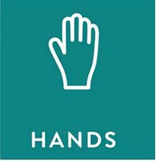
Participate in a 4-H county, city, multi-county, regional, or state overnight experience (i.e., Maryland 4-H Congress, Issue Forum, etc.). (self-motivation)
Participate in a state, national, or international 4-H event. (self-motivation) Promote a 4-H club or event using a format or venue that you think will be the most effective. (marketable skills, contribution to group effort)
Teach a community group about an issue of importance in your area. Explain why the issue is important, demonstrate how individuals and groups can help, and describe at least one community agency that is involved. (responsible citizenship)
Serve as an officer or committee or program chair or leader for a club or group (i.e., county/city or state 4-H committee, national group, school group, community committee, etc. (leadership)
Self-determined. Apply a life skill from 4-H to another area of your life.
Goal: Life Skill:

Attend at least 80% of 4-H meetings or trainings. (self-responsibility) Complete a healthy living-related project in an area that is new to you. (healthy lifestyle choices)
Teach others in a club or group meeting or community organization meeting or event about the importance of valuing and accepting others from diverse backgrounds. (self-esteem)
Teach fellow club or group members about the importance of safety as it relates to 4-H meetings and events. (personal safety)
Self-determined. Apply a life skill from 4-H to another area of your life.
Goal: Life Skill:

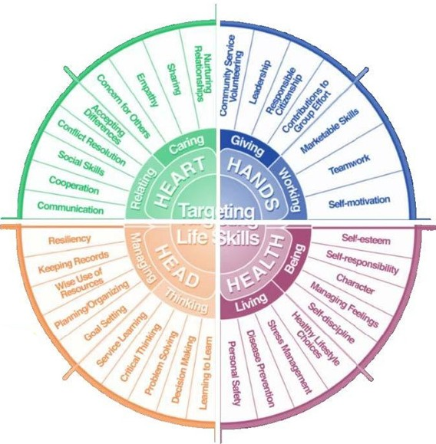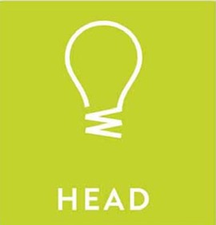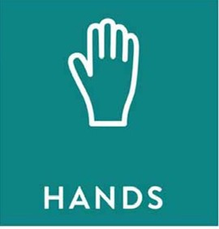

Hendricks Life Skills Wheel

Section 2: Youth and Adult Signatures
I have chosen a minimum of seven goals for my Level 5 project. I will request support as needed to ensure the achievement of my goals.

4-H Member Signature: Date:

I have reviewed this plan and find it complete, accurate, and acceptable to meet the requirements of the Maryland 4-H Diamond Clover Level Five project. I am willing to support the 4-H member to ensure the achievement of this project.

Parent/Guardian Signature: Date:

Club/Group Leader Signature: Date:

Section 3: Youth Reflection

List the completed goals and the dates they were completed. Explain how you used the related life skills to accomplish the goals. Note: Goals do not need to be reached in a particular order.

First Goal: Date:

Explain how you used a life skill to reach this goal.

Second Goal: Date:

Explain how you used a life skill to reach this goal.

Third Goal: Date:

Explain how you used a life skill to reach this goal.

Fourth Goal: Date:

Explain how you used a life skill to reach this goal.

Fifth Goal: Date:

Explain how you used a life skill to reach this goal.

Sixth Goal: Date:

Explain how you used a life skill to reach this goal.

Seventh Goal: Date:

Explain how you used a life skill to reach this goal.

I have reviewed this report and find it to be complete, accurate, and meeting the requirements of
this level as part of the Maryland 4-H Diamond Clover Award Program.

4-H Member Signature: Date:

4-H Parent/Guardian Signature: Date:

4-H Club/Group Leader Signature: Date:

4-H Educator Signature: Date:

University programs, activities, and facilities are available to all without regard to race, color, sex, gender identity or expression, sexual orientation, marital
status, age, national origin, political affiliation, physical or mental disability, religion, protected veteran status, genetic information, personal appearance, or
any other legally protected class. 5

