4-H Rabbit and Cavy Project

MARYLAND 4-H ANIMAL SCIENCE -
RABBIT AND CAVY PROJECT RECORD

Name |  | 4-H Age
Primary Club Name
Years in 4-H |  | Years in this Project:
I have completed this record and believe all information to be complete and accurate. (Print and sign/date.)

____________________________ ________________ ___________________________ _______________
Member’s Signature Date Parent’s Signature Date

Please indicate your Animal Science Project Area
 | Rabbit (Breeding) |  | Rabbit (Market) |  | Cavy

What goals did you set for your project this year and how did you achieve them?

What were two things you learned from completing this project this year?

What is one thing you would like to improve or do differently with your project next year?

Life Skills
Describe the Life Skills you used and what you learned in relation to your project.

Example Table
I used one or more of these Life Skills from the Targeting Life Skills Wheel | What I learned as a result of using this skill.
HEAD  Example: Decision Making | I learned that I needed to be sure to budget my money when purchasing my rabbit projects so I would have enough to cover all of my expenses.
HEART  Example: Sharing | I learned how to give younger 4-H members pointers on how to fit and show their animals properly
HAND  Example: Healthy Life Choices | I learned that animals don’t grow well unless they receive the proper food.
HEALTH  Example: Managing Feelings | I learned to control my feelings when I became frustrated that my pig would not cooperate to get loaded on the trailer.

I used one or more of these Life Skills from the Targeting Life Skills Wheel | What I learned as a result of using this skill.
HEAD

HEART

HAND

HEALTH

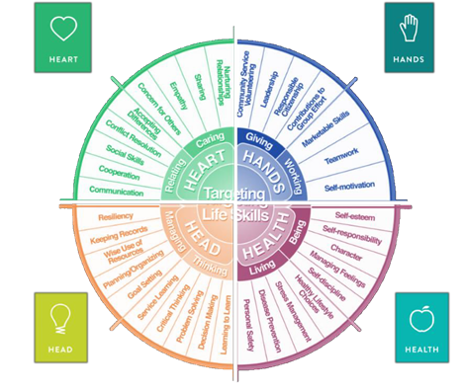

MARYLAND 4-H RABBIT AND CAVY PROJECT RECORD

Project Activities
Include: Field Trips. Skillathon, Judging, Workshops, Quality Assurance, Class Participation, etc.
All project activities listed should be about this project area only.
Date | Name of Activity/Event | Location  (school, club, county, state, national, etc.)

Project Communications
Include: Speeches, Demonstrations, Visual Presentations, etc.
All project communications listed should be about this project area only.
Date | Type of Communication | Title | Location  (school, club, county, state, national, etc.)

Project Exhibits
Include: Fair, Shows, Community Events, Contests, etc. All project exhibits listed should be for this project area only.
Date | Exhibit/Class | Event/Activity | Placing
Table 1: Rabbit/Cavy Inventory
(Also include those sold/died)
Animal Name/Tattoo # | Breed | Sex | Date of Birth | Value or Cost at Start | Animal Status (Own, Sold, Died) | Value at End
Total Value

Table 2: Breeding Information
(Only include those who are breeding age)
Name/Tattoo # | Date Gave Birth | Date Bred | Number Born | Number Weaned | Name of Sire/Tattoo #

Table 3: Feed Record Expenses
Month | Type of Feed | Quantity Feed | Cost
Total Feed Costs

Table 4: Health and Veterinary Expenses
Date (s) Treated | Name/Tattoo # | Reason for Treatment or Veterinary Visit | Treatment | Cost
Total Health and Veterinary Cost

Table 5: All Other Expenses
Include: Supplies, Equipment, etc.
Date | Explanation of Expense | Cost
Total of All Other Expenses

Table 6: All Income
Include income from project animals including premiums, sale of animals, etc.
Date | Description of Income | Income $
Total Income

Financial Summary: Please make sure to use the above totals.
Determine how much money you made or lost on your project animals. You can determine your profit/loss by:
- Income | - Value of Animals on Hand at the End of Project (Table 1) | $
 | - All Income (Table 6)
 | Total Income (A) | $
- Expenses | - Project Animal Costs (Table 1 - Value at Start) | $
 | - Feed Expenses (Table 3) | $
 | - Health and Veterinary Expenses (Table 4) | $
 | - All Other Expenses (Table 5)
 | Total Expenses (B) | $
- Total | Subtract B from A to get total | $  (Profit or loss)

