4-H Poultry Project

MARYLAND 4-H ANIMAL SCIENCE -
POULTRY PROJECT RECORD
Name |  | 4-H Age
Primary Club Name
Years in 4-H |  | Years in this Project:
I have completed this record and believe all information to be complete and accurate. (Print and sign/date.)

____________________________ ________________ ___________________________ _______________
Member’s Signature Date Parent’s Signature Date

Please select your 4-H Project below: (check all that apply)
Chickens |  |  | Gamebirds (quail, pigeons, guinea fowl, partridges, pheasants)
 | Broiler/Roaster (Meat Production/Market) |  | Turkeys
 | Egg Production |  | Waterfowl (ducks and geese)
 | Fancy Birds

What goals did you set for your project this year and how did you achieve them?

What were two things you learned from completing this project this year?

What is one thing you would like to improve or do differently with your project next year?

Life Skills
Describe the Life Skills you used and what you learned in relation to your project.

Example Table
I used one or more of these Life Skills from the Targeting Life Skills Wheel | What I learned as a result of using this skill.
HEAD  Example: Decision Making | I learned that I needed to be sure to budget my money when purchasing my rabbit projects so I would have enough to cover all of my expenses.
HEART  Example: Sharing | I learned how to give younger 4-H members pointers on how to fit and show their animals properly.
HAND  Example: Healthy Life Choices | I learned that animals don’t grow well unless they receive the proper food.
HEALTH  Example: Managing Feelings | I learned to control my feelings when I became frustrated that my pig would not cooperate to get loaded on the trailer.

I used one or more of these Life Skills from the Targeting Life Skills Wheel | What I learned as a result of using this skill.
HEAD

HEART

HAND

HEALTH

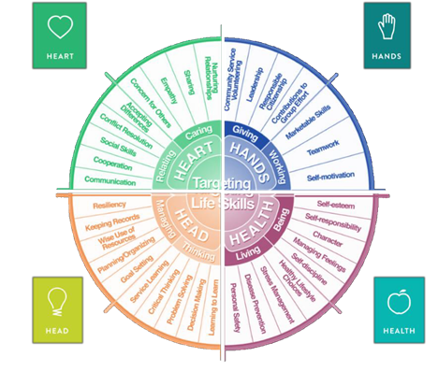

MARYLAND 4-H LARGE POULTRY PROJECT RECORD

Project Activities
Include: Field Trips. Skillathon, Judging, Workshops, Quality Assurance, Class Participation, etc.
All project activities listed should be about this project area only.
Date | Name of Activity/Event | Location  (school, club, county, state, national, etc.)

Project Communications
Include: Speeches, Demonstrations, Visual Presentations, etc.
All project communications listed should be about this project area only.
Date | Type of Communication | Title | Location  (school, club, county, state, national, etc.)

Project Exhibits
Include: Fair, Shows, Community Events, Contests, etc. All project exhibits listed should be for this project area only.
Date | Exhibit/Class | Event/Activity | Placing

Table 1: Poultry Inventory
Animal Name/ Band Number or Lot Number | Breed | Color/ Variety | Sex | Date of Hatch | Date of Purchase (if applicable) | Value at Beginning or Cost of Purchased | Current Status (Own, Sold, or Died) | Value at End
Total |  |  |  |  |  |  | Total at Project End

Table 2: Breeding Information
(only include those who are breeding age)
Animal/Band Number | Date Bred | Male Used for Breeding | Date Chicks Hatched | Number Hatched | Number Raised

Table 3: Incubation and Hatching Information
Date Eggs Set | Number Eggs Set | Date Chicks Hatched | Number Hatched | Number Raised | Incubation Method Used

Table 4: Feeding Information and Expenses
Date | Type of Feed | Quantity of Feed/Day | Cost
Total Feed Cost

Table 5: Health and Veterinary Record and Expenses
(Vaccines, Blood Testing, Routine Checks, etc.)
Date (s) Treated | Reason for Treatment/Visit | Treatment | Number of Animals Treated | Withdrawal Period |  | Cost
 |  |  |  | Days | Date completed
Total Health and Veterinary Costs

Table 6: All Other Expenses
Includes: Equipment, Supplies, Processing, etc.
Date | Description of Item or Expense | Cost
Total of All Other Expenses

Table 7: Egg Production
Week | Number of Eggs Produced | Variety of Eggs | Value of Eggs Produced | Week | Number of Eggs Produced | Variety of Eggs | Value of Eggs Produced
Total Value of Egg Sales |  |  |  | Total Value of Egg Sales

Table 8: Poultry and Meat Sales
Date | Number Sold (Birds or Pounds) | Type Sold (Live Poultry, Meat) | Value
Total Value of Poultry and Meat Sales

Financial Summary: Please make sure to use the above totals.
Determine how much money you made or lost on your project animals. You can determine your profit/loss by:
- Income | - Value of Animals on Hand at the End of the Project (Table 1) | $
 | - Money Received from Sale of Eggs (Table 7) | $
 | - Money Received from Sale of Live Poultry or Meat (Table 8)
 | Total Income (A) | $
- Expenses | - Total Value of Animals on Hand and Purchased (Table 1) | $
 | - Feed Expenses (Table 4) | $
 | - Health and Veterinary Expenses (Table 5) | $
 | - All Other Expenses (Table 6) | $
 | Total Expenses (B) | $
- Total | Subtract B from A to get total | $  (Profit or loss)

