4-H Breeding Project

MARYLAND 4-H ANIMAL SCIENCE -
LARGE ANIMAL BREEDING PROJECT RECORD

Name |  | 4-H Age
Primary Club Name
Years in 4-H |  | Years in this Project:
I have completed this record and believe all information to be complete and accurate. (Print and sign/date.)

____________________________ ________________ ___________________________ _______________
Member’s Signature Date Parent’s Signature Date

Please indicate your Animal Science Project Area
 | Beef (Breeding) |  | Goat (Meat Breeding) |  | Goat (Dairy Breeding) |  | Horse (Breeding)
 | Sheep (Breeding) |  | Swine (Breeding)

What goals did you set for your project this year and how did you achieve them?

What were two things you learned from completing this project this year?

What is one thing you would like to improve or do differently with your project next year?

Life Skills
Describe the Life Skills you used and what you learned in relation to your project.

Example Table
I used one or more of these Life Skills from the Targeting Life Skills Wheel | What I learned as a result of using this skill.
HEAD  Example: Decision Making | I learned that I needed to be sure to budget my money when purchasing my rabbit projects so I would have enough to cover all of my expenses.
HEART  Example: Sharing | I learned how to give younger 4-H members pointers on how to fit and show their animals properly.
HAND  Example: Healthy Life Choices | I learned that animals don’t grow well unless they receive the proper food.
HEALTH  Example: Managing Feelings | I learned to control my feelings when I became frustrated that my pig would not cooperate to get loaded on the trailer.

I used one or more of these Life Skills from the Targeting Life Skills Wheel | What I learned as a result of using this skill.
HEAD

HEART

HAND

HEALTH

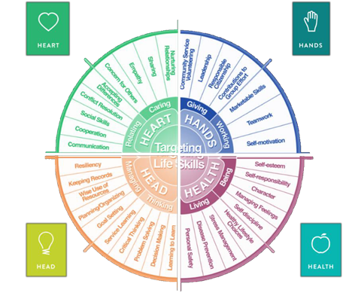

MARYLAND 4-H LARGE ANIMAL BREEDING PROJECT RECORD

Project Activities
Include: Field Trips, Skillathon, Judging Workshops, Quality Assurance, Class Participation, etc.
All project activities listed should be about this project area only.
Date | Name of Activity/Event | Location  (school, club, county, state, national, etc)

Project Communications
Include: Speeches, Demonstrations, Visual Presentations, etc.
All project communications listed should be about this project area only.
Date | Type of Communication | Title | Location  (school, club, county, state, national, etc.)

Project Exhibits
Include: Fair, Shows, Community Events, Contests, etc. All project exhibits listed should be for this project area only.
Date | Exhibit/Class | Event/Activity | Placing
Table 1: Project Animal Information
Animal Name/ Tag #/ Tattoo | Breed | Sex | Date of Birth | Dam | Sire | Cost
Total Cost of Animal Projects Purchased

Table 2: Animal Breeding Information
(only include those who are breeding age)
Animal Name/ Tag #/ Tattoo | Date Bred | Date Gave Birth | Number Born | Number Weaned | Type of Breeding (N-Natural, AI-Artificial Insemination, ET- Embryo Transplant) | Sire | Cost

Table 3: Offspring Record
Animals born as a result of animal breeding information in Table 2.
Animal Name/ Tag #/ Tattoo | Date of Birth | Dam | Sire | Birth Weight | Animal Status (sold, kept for breeding, died, etc.)
Table 4: Feed Expenses
Date Purchased | Type of feed (grain, mix, hay, supplement, pasture, silage) | $/lb (total cost divided by lbs) | Pounds (lbs) | Total Cost
Total pounds and total feed costs

Table 5: Health and Veterinary Expenses
(If leasing an animal, you still need to complete the health and veterinary expenses.)
List practices & materials used to treat or protect your animals from parasites, illnesses, & diseases. Include veterinary examinations, health papers, treatments for illnesses or injuries, foot care, vaccinations, medications & dewormers. etc.
Date (s) Treated | 4-H Tag # or Animal ID | Reason for Treatment or Veterinary Visit | Treatment Given | Withdrawal Period |  | Cost
 |  |  |  | Days | Date completed
Total Health and Veterinary Costs

Table 6: All Other Expenses
(Equipment, Supplies, etc.)
Date | Description of Item or Expense | Cost
Total of All Other Expenses

Table 7: Income Record
Income from sale of Offspring and/or Project Animal(s)
Date | Description of Income | Income $
Total Income

Table 8: All Other Income
Include all other income from project animal(s) including premiums, products (wool, soap, milk, etc.)
Date | Description of Income  (sale of milk can be listed monthly) | Income $
Total Income

Table 9: Milk Record
(Dairy Animals Only)
Month | Pounds of Milk (approximate) | Month | Pounds of Milk (approximate)
Total Milk Production

Financial Summary: Please make sure to use the above totals.
Determine how much money you made or lost on your project animals. You can determine your profit/loss by:
- Income | - Money received from sale of offspring and/or project animals (Table 7) | $
 | - All Other Income (Table 8) | $
 | Total Income (A) | $
- Expenses | - Project Animal Costs (Table 1) | $
 | - Feed Expenses (Table 4) | $
 | - Health and Veterinary Expenses (Table 5) | $
 | - All Other Expenses (Table 6) | $
 | Total Expenses (B) | $
- Total | Subtract B from A to get total | $  (Profit or loss)

