4-H Horse Project

MARYLAND 4-H ANIMAL SCIENCE -
HORSE PROJECT RECORD

Name |  | 4-H Age
Primary Club Name
Years in 4-H |  | Years in this Project:
I have completed this record and believe all information to be complete and accurate. (Print and sign/date.)

____________________________ ________________ ___________________________ _______________
Member’s Signature Date Parent’s Signature Date

What goals did you set for your project this year and how did you achieve them?

What were two things you learned from completing this project this year?

What is one thing you would like to improve or do differently with your project next year?

Life Skills
Describe the Life Skills you used and what you learned in relation to your project.

Example Table
I used one or more of these Life Skills from the Targeting Life Skills Wheel | What I learned as a result of using this skill.
HEAD  Example: Decision Making | I learned that I needed to be sure to budget my money when purchasing my rabbit projects so I would have enough to cover all of my expenses.
HEART  Example: Sharing | I learned how to give younger 4-H members pointers on how to fit and show their animals properly.
HAND  Example: Healthy Life Choices | I learned that animals don’t grow well unless they receive the proper food.
HEALTH  Example: Managing Feelings | I learned to control my feelings when I became frustrated that my pig would not cooperate to get loaded on the trailer.

I used one or more of these Life Skills from the Targeting Life Skills Wheel | What I learned as a result of using this skill.
HEAD

HEART

HAND

HEALTH

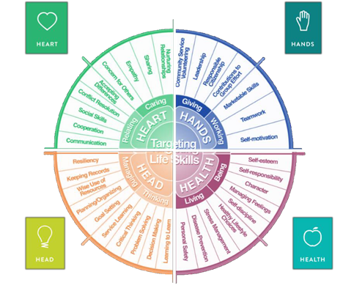

MARYLAND 4-H HORSE PROJECT RECORD

Project Activities
Include: Field Trips. Skillathon, Judging, Workshops, Quality Assurance, Class Participation, Etc.
All project activities listed should be about this project area only.
Date | Name of Activity/Event | Location  (school, club, county, state, national, etc.)

Project Communications
Include: Speeches, Demonstrations, Visual Presentations, etc.
All project communications listed should be about this project area only.
Date | Type of Communication | Title | Location  (school, club, county, state, national, etc.)

Project Exhibits
Include: Fair, Shows, Community Events, Contests, etc. All project exhibits listed should be for this project area only.
Date | Horse’s Name  (if applicable) | Exhibit/Class | Event/Activity | Placing
Table 1: Horse/Pony Information
 | Horse #1 | Horse #2 | Horse #3
Show/Registered Name
Barn Name
Color
Markings (be specific)
Height
Breed
Breed Registry Info (if applicable)
Animal’s Date of Birth

Table 2: Feed Expenses
Date Purchased | Type of feed (grain, mix, hay, supplement, pasture, silage) | $/lb (total cost divided by lbs) | Pounds (lbs) | Total Cost
Total pounds and total feed costs

Table 3: Health and Veterinary Expenses
Record routine and emergency veterinary visits and include specific shots, Coggins, dentistry, deworming, test(s) performed, etc. If you lease a horse and are not directly responsible for these expenses, you must still complete these sections.
Date (s) Treated | Horse’s Name | Reason for Treatment or Veterinary Visit | Treatment Given | Cost
Total Veterinary Costs

Table 4: Farrier Record and Expenses
Record each Farrier visit as it occurs. Place an X in the appropriate box for trim, shoe, or reset.
Date (s) Treated | Horse’s Name | Trim | Shoe | Reset | Cost
Total Farrier Expenses

Table 5: All Other Expenses
Includes: hauling, tack, equipment, insurance, board, membership fees, bedding, training, etc.
Date | Description of Item or Expense | Cost
Total of All Other Expenses

Table 6: Income Record
Income all monies received as part of your project (premiums, sale of services, sale of horse(s), etc.
Date | Description of Income | Income $
Total Income

Table 7: Horsemanship Standards Information
Please complete the chart regarding the Horsemanship Standards that you have completed. Include the month and year for each level that has been completed.
 | Knowledge | English | Riding Western | Jumping
Level 1
Level 2
Level 3
Level 4
Level 5
Level 6

Financial Summary: Please make sure to use the above totals.
Determine how much money you made or lost on your project animals. You can determine your profit/loss by:
- Income | - All Income (Table 6) | $
 | Total Income (A) | $
- Expenses | - Feed Expenses (Table 2) | $
 | - Veterinary Expenses (Table 3) | $
 | - Farrier Expenses (Table 4) | $
 | - All Other Expenses (Table 5) | $
 | Total Expenses (B) | $
- Total | Subtract B from A to get total | $  (Profit or loss)

