MARYLAND 4-H GENERAL PROJECT RECORD

4-H
Project
Record

Name |  |  | 4-H Age
Primary Club Name
Years in 4-H |  |  | Years in this Project
I have completed this record and believe all information to be complete and accurate.

Member’s Signature Date Parent’s Signature Date Club Leader Signature (If required by county/city)

What goals did you set for your project this year and how did you achieve them?

Project being completed in this record:
What were two things you learned from completing this project this year?
1.
2.

What is one thing you would like to improve or do differently with your project next year?

MARYLAND 4-H GENERAL PROJECT RECORD

Life Skills

Describe the Life Skills you used and what you learned in relation to your project.

Example Table

I used one or more of these Life Skills  from the Targeting Life Skills Wheel | What I learned as a result of using this skill.
HEAD  Example: Decision Making | I learned that I needed to be sure to budget my money when purchasing craft supplies so I would  have enough to cover all of my expenses.
HEART  Example: Sharing | I learned how to give younger 4-H members pointers on how to make a wreath through a visual  presentation.
HAND  Example: Community Service Volunteering | Through my woodworking project, I have learned many new skills. I found it to be beneficial to  my community to utilize those woodworking skills when volunteering to build a wheel chair ramp.
HEALTH  Example: Managing Feelings | I learned to control my feelings when I became frustrated that the new cake I baked didn’t rise.  Since I didn’t have success with the new cake recipe, I am going to research other options that I could try.

I used one or more of these Life Skills  from the Targeting Life Skills Wheel | What I learned as a result of using this skill.
HEAD
HEART
HAND
HEALTH

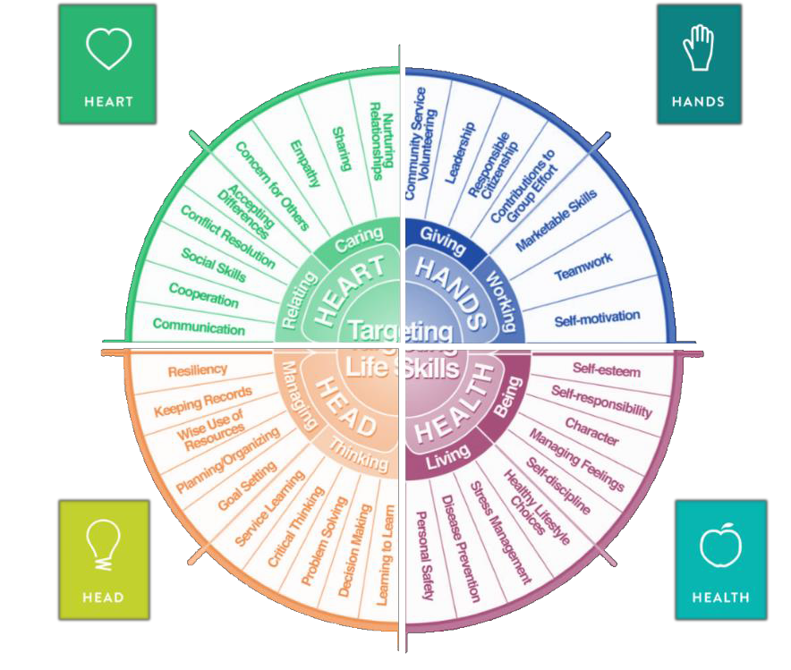
The diagram below shows many of the Life Skills learned in 4-H:

Courtesy of Iowa State University-Used with Permission 11/2012

MARYLAND 4-H GENERAL PROJECT RECORD

Project Activities/Learning Experiences and Project Resources
Include: Field Trips, Meetings, Workshops, any Learning Experiences, etc.
All project activities/learning experiences listed should be about this project area only.
Date | Name of Activity/Event/Learning Experience/Resource | What I Learned

Project Communications
Include: Speeches, Demonstrations, Visual Presentations, Etc.
All project communications listed should be about this project area only.
Date | Type of Communication | Title | Location  (School, Club, County, Regional, State, National etc.)

Project Exhibits
Include: Fairs, Shows, Community Events, Contests, etc. All project exhibits listed should be for this project area only.
Date | Exhibit/Class | Event/Activity | Placing  (if applicable)

MARYLAND 4-H GENERAL PROJECT RECORD

Table 1: Project Expenses
Include all costs associated with project. Examples: Ingredients, Paint, Wood, Fabric, Fees, Lessons, Services, Resources, etc.
Date | Description of Item Purchased | Cost
Total Expenses

Table 2: All Income
Includes: Premiums, Selling Project Work Items, etc.
Date | Description of Income | Income Amount
Total Income

MARYLAND 4-H GENERAL PROJECT RECORD

Financial Summary: Please make sure to use the totals from Tables 1 and 2.

Determine how much money you made or lost on your project. Profit or loss is no indication of project success. Profit means your project brought in more income than you brought in and profit loss means your project brought in less than you spent. This does not necessarily indicate the quality of a project. You can determine your profit (or loss) by:

Income

  - Income Total (Table 2) $

Total Income (A) $

Expenses
$
  - All Expenses (Table 1)

Total Expenses (B) $

Subtract B from A to get profit or loss Total $
(profit or loss)

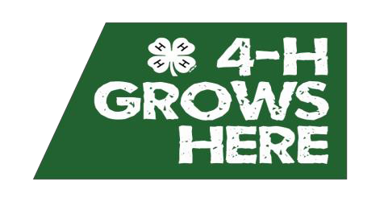

University of Maryland Extension programs are open to all and will not discriminate against anyone because of race, age, sex, color, sexual orientation, physical or mental disability, religion, ancestry or national origin, marital status, genetic information, political affiliation, or gender identity and expression.

