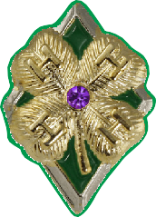Address: Town/State/Zip: 4-H County or Baltimore City: Club(s):
Maryland 4-H Diamond Clover Award Program
Level 1 (Amethyst)
Name: Phone:

4-H Age:
Birth Date:
Years in 4-H: (including this year)

Directions: At the beginning of the year, complete section 1 and 2 with the appropriate signatures.
At the end of the year, complete section 3 with the appropriate signatures. A 4-H Club/Group Leader must approve the Diamond Clover Plan prior to when you start the activities.

Section 1: Diamond Clover Level 1 Goals Checklist
Choose at least five goals for this year: You are encouraged to choose goals from all four H categories. You may also write in a maximum of two self-determined goals. 4-H life skills are shown in italics.

Complete at least one 4-H project from a new area and keep records.

(keeping records, learning to learn)
Identify a local civic engagement, non-profit, community service, or government
agency or committee and research its purpose.

(critical thinking, decision making, service learning)
Keep a log of all purchases and expenses for at least one 4-H project. (keeping records)
Self-determined. Apply a life skill from 4-H to another area of your life.
Goal: Life Skill:

Assist with a club or community service learning project. (concern for others)
Assist with a club or community fundraiser. (concern for others)
With the permission of your parent/guardian, contact an adult mentor or teen leader through a letter, e-mail, or phone call to ask for assistance with a project or activity. (nurturing relationships)
Participate in a communication event (public speaking, visual presentation/workshop, etc.). (communication)
Self-determined. Apply a life skill from 4-H to another area of your life.
Goal: Life Skill:

University programs, activities, and facilities are available to all without regard to race, color, sex, gender identity or expression, sexual orientation, marital
status, age, national origin, political affiliation, physical or mental disability, religion, protected veteran status, genetic information, personal appearance, or
any other legally protected class. 1

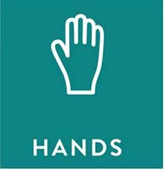
Lead 4-H Pledge. (leadership)
Give a presentation, workshop, or demonstration at a meeting. (leadership)
Participate in a county/city activities or workshops. (self-motivation)
Teach a group about a topic of importance in your area. Identify why this topic is important and how it affects the community. (responsible citizenship)
Serve as an officer or a committee or program chair/leader for a club or group (i.e., 4-H
club, school group, community committee, etc.). (leadership)
Self-determined. Apply a life skill from 4-H to another area of your life.
Goal: Life Skill:

Attend at least 60% of 4-H meetings or trainings. (self-responsibility)
Prepare a healthy snack for a club or group meeting. (healthy lifestyle choices)
Help a new 4-H member or family feel welcome at a club or group meeting or activity .

(self-esteem)
Inspect a meeting area to make sure it is safe. Tell an adult if you find safety hazards.

(personal safety)
Self-determined. Apply a life skill from 4-H to another area of your life.
Goal: Life Skill:

Section 2: Youth and Adult Signatures
I have chosen a minimum of five goals for my Level 1 project. I will request support as needed to ensure the achievement of my goals.

4-H Member Signature: Date:

I have reviewed this plan and find it complete, accurate, and acceptable to meet the requirements of the Maryland 4-H Diamond Clover Level One project. I am willing to support the 4-H member to ensure the achievement of this project.

Parent/Guardian Signature: Date:

Club/Group Leader Signature: Date:

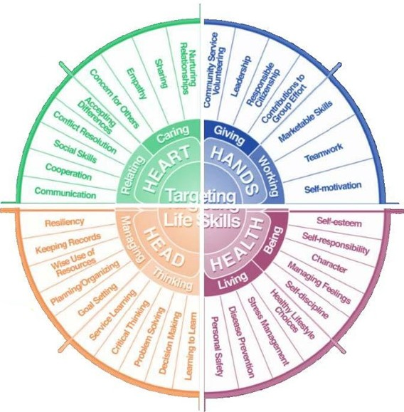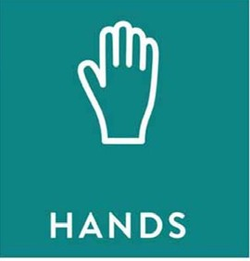

Hendricks Life Skills Wheel

Section 3: Youth Reflection

List the completed goals and the dates they were completed. Explain how you used the related life skills to accomplish the goals. Note: Goals do not need to be reached in a particular order.

First Goal: Date:

Explain how you used a life skill to reach this goal.

Second Goal: Date:

Explain how you used a life skill to reach this goal.

Third Goal: Date:

Explain how you used a life skill to reach this goal.

Fourth Goal: Date:

Explain how you used a life skill to reach this goal.

Fifth Goal: Date:

Explain how you used a life skill to reach this goal.

I have reviewed this report and find it to be complete, accurate, and meeting the requirements of
this level as part of the Maryland 4-H Diamond Clover Award Program.

4-H Member Signature: Date:

4-H Parent/Guardian Signature: Date:

4-H Club/Group Leader Signature: Date:

University programs, activities, and facilities are available to all without regard to race, color, sex, gender identity or expression, sexual orientation, marital
status, age, national origin, political affiliation, physical or mental disability, religion, protected veteran status, genetic information, personal appearance, or
any other legally protected class. 5

