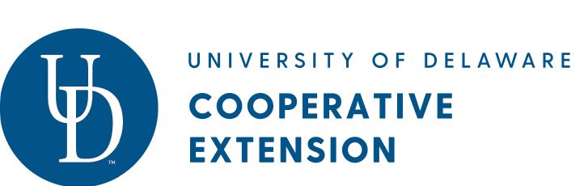

Focus on Farmers and Ranchers - What to Do if You’ve Lost Your Health Insurance Due to the Coronavirus Crisis
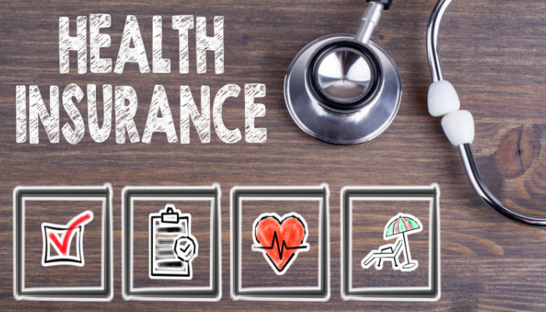
Farmers and Ranchers often rely on employer-based health insurance to cover themselves or their families. Whether the business that provides this benefit for you is shutting down temporarily or it is scaling back its staff, make sure to ask them when the last day of health coverage is. This will help you better understand what timeline you have for your existing health care coverage. It helps ensure that you don’t have a gap in your coverage when, during this time of a health crisis, it is important to have health care coverage. Once you have this information, there are some steps you can take to ensure you have health insurance to keep you and your family healthy.

If you need to refresh your understanding of health insurance and how to choose the right type of insurance or estimate the out of pocket costs, go to this UD Cooperative Extension website for some video tutorials and tools to help you brush up on your knowledge. http://udel.edu/extension/insure and look for Health Insurance 4U.

Once you are feeling more confident about health insurance, it’s time to consider your options:

- Sign up for COBRA
Short for the Consolidated Omnibus Budget Reconciliation Act this option allows you to retain and continue your current employer health coverage for up to 18 months. In this way, everything you’re used to stays the same – same doctors, networks, co-pays, and deductibles. The downside is that you will pay your entire monthly health insurance premiums yourself. That premium will include the part you usually paid plus any amount your employer was paying. You’ll want to find out if this option is financially feasible for you.

- Sign on to your Spouse’s Health Coverage
If your spouse has health insurance, you may be able to be added to your spouse’s healthcare plan coverage. Have your spouse talk with their human resources department to ask what options are available. The cost of that coverage will come out of your spouse’s paycheck so before you make the decision, you may want to comparison shop.

- Buy your own plan on the health insurance Marketplace
The Affordable Care Act introduced an online health insurance Marketplace that allows you to buy your own private plan. You're generally entitled to apply for a new plan if you lose your existing health coverage, even though the annual open-enrollment period to sign up for Marketplace plans has passed.

In Delaware, there is a window of opportunity to buy a Marketplace plan when you have lost your job or health insurance coverage. You have 60 days before your current health insurance plan expires and 60 days after your plan expires. If you don’t enroll during this time period, you can’t enroll through the Marketplace and need to wait until open enrollment in October of each year.

In Delaware, you can find information about this Marketplace at www.choosehealthDE.com
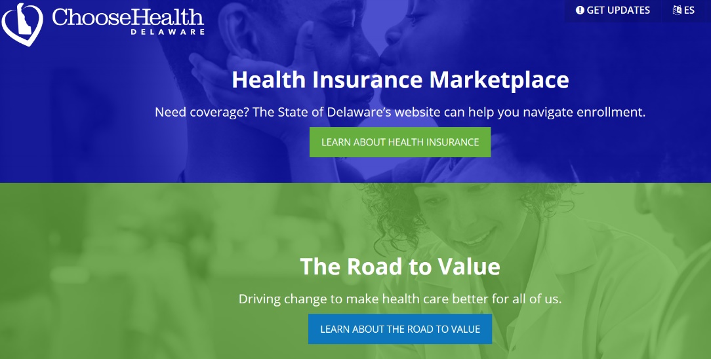
The benefit of the Marketplace plans is that depending on your income, you may qualify for subsidies and tax credits. This can reduce the cost of the premiums. There are several different plans to choose from. All of them have a deductible (the amount you need to pay before health insurance pays for care) and typically the lower the monthly premiums, the higher the deductible. If you qualify for those tax credits and subsidies for the premium, that may offset the higher deductible amount and so your overall out of pocket costs may even out.

Be advised, that in order to get those credits and subsidies, you need to purchase the plans through the Marketplace or an accredited health insurance broker/ provider. Talking with a Marketplace Navigator is a great way to find out your options. They can be found on the website above.

To find out how much of a subsidy you may qualify for you can go to this website: https://www.healthcare.gov/lower-costs/. It will ask you for some information and then will direct you to the next steps.

- Apply for Medicaid and/or Child Health Insurance Program (CHIP)
Medicaid and CHIP provides free or low-cost health coverage to millions of Americans, including some low-income people, families and children, pregnant women, the elderly, and people with disabilities. If your income is low, you may be eligible for Medicaid (covers families) or the Children’s Health Insurance Program (covers children only). To find out if you can qualify go to https://www.healthcare.gov/screener/, fill out the online form and determine the next steps.

In Delaware, you can also go to the DE Assist website which is a one-stop-website that helps you apply for not only Medicaid and CHIP but other assistance programs. This website URL is: https://assist.dhss.delaware.gov/

Being without health insurance during this time can be scary. Take the steps you need to protect your family now and in the future. Your wellbeing now and in the future will depend on it.
__________
Written by Maria Pippidis, University of Delaware Cooperative Extension. You have permission to adapt this material for your state but please provide attribution.
University of Delaware Cooperative Extension in accordance with Federal civil rights law and U.S. Department of Agriculture (USDA) civil rights regulations and policies, the USDA, its Agencies, offices, and employees, and institutions participating in or administering USDA programs are prohibited from discriminating based on race, color, national origin, religion, sex, gender identity (including gender expression), sexual orientation, disability, age, marital status, family/parental status, income derived from a public assistance program, political beliefs, or reprisal or retaliation for prior civil rights activity, in any program or activity conducted or funded by USDA (not all bases apply to all programs). Remedies and complaint filing deadlines vary by program or incident.

