COMMON EVERYDAY NATIVE PLANTS to MARYLAND

Flowering Herbaceous Perennials

Common Name | Botanical Name | Season of Bloom
Alumroot | Heuchera americana | Spring
Beardtongue | Penstemon digitalis | Summer
Bee Balm | Monarda didyma | Summer
Bergamot, Wild | Monarda fistulosa | Summer
Black-eye Susans | Rudbeckia hirta | Summer
Bleeding Heart, Wild | Dicentra eximia | Spring
Bluebells, Virginia | Mertensia virginica | Spring
Butterfly Weed | Asclepia tuberosa | Spring
Cardinal Flower | Lobelia cardinalis | Summer
Great Blue Lobelia | Lobelia siphilitica | Summer
Coneflower, Early | Rudbeckia fulgida | Summer/Fall
Columbine, Wild | Aquilegia Canadensis | Spring
Coreopsis, Pink | Coreopsis rosea | Summer
Flag, Blue | Iris versicolor | Spring
Flag, Sweet | Acorus calamus | Spring
Foamflower | Tiarella cordifolia | Spring
Gayfeather | Liatris spicata | Summer
Geranium, wild | Geranium maculatum | Spring/Summer
Goldenrod, Seaside | Solidago sempervirens | Summer/Fall
Goldenrod, Silver Rod | Solidago bicolor | Summer/Fall
Goldenrod, Wrinkle Leaf | Solidago rugosa | Summer/Fall
Indian Pink | Spigelia marilandica | Spring
Indigo, Blue False | Baptisia australis | Spring
Indigo, Wild | Baptisia tinctoria | Spring
Joe-Pye Weed | Eupatorium Fistulosum | Summer
Mallow, Rose | Hibiscus moscheutos | Summer
Marigold, Marsh | Caltha palustris | Spring
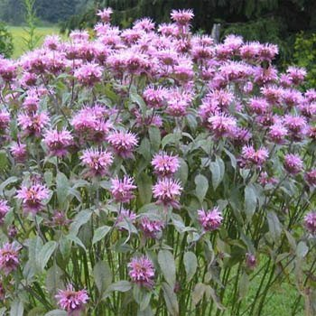  May Apple | Podophyllum peltatum | Spring
Milkweed, Swamp | Asclepias incarnate | Spring
Obedient Plant | Physotegia virginiana | Summer
Phlox, Blue | Phlox divaricata | Spring
Phlox, creeping | Phlox stolonifera | Spring
Phlox, moss | Phlox subulata | Spring
Phlox, summer | Phlox paniculata | Summer
Pickerelweed | Pontederia cordata | Summer/Fall
Snakeroot | Cimicifuga racemosa | Summer
Speedwell | Veronica officinalis | Summer
Spiderwort | Tradescantia virginiana | Spring/Summer
Sunflower, Swamp | Helianthus angustifolius | Summer
Tickseed | Coreopsis verticillata | Summer
Turtlehead | Chelone glabra | Summer/Fall

COMMON EVERYDAY NATIVE PLANTS to MARYLAND

Flowering Shrubs

Common Name | Botanical Name | Season of Bloom
Azalea, Dwarf | 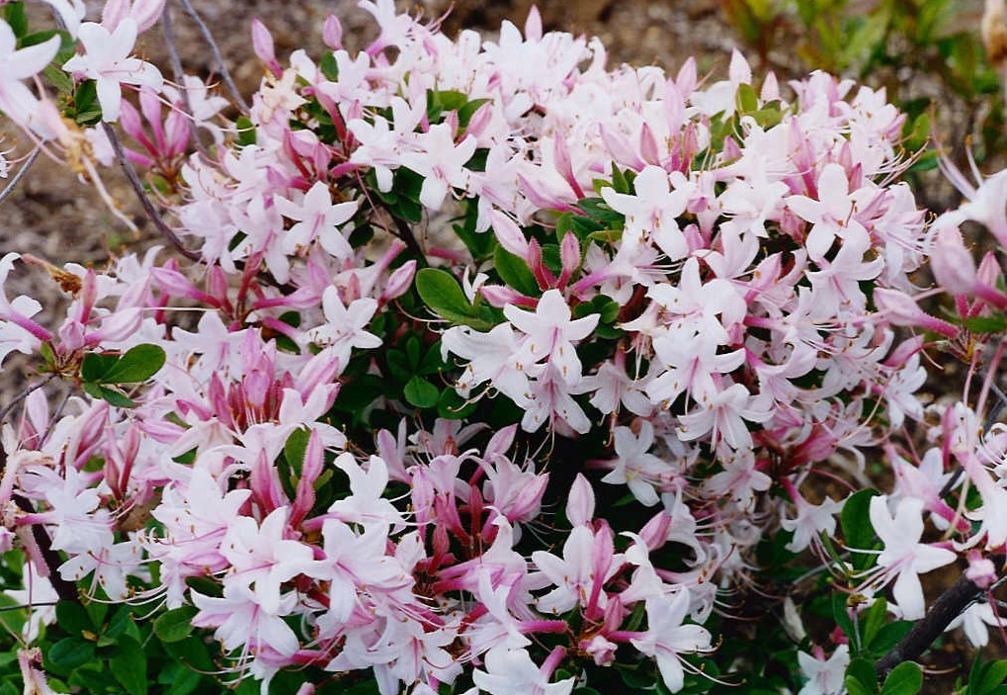  Rhododendron atlanticum | Spring
Azalea, Pink | Rhododendron periclymenoides | Spring
Azalea, Swamp | Rhododendron viscosum | Spring
Azalea, Sweet | Rhododendron canescens | Spring
Bayberry, Northern | Myrica pensylvanica | Spring
Blueberry, Early Lowbush | Vaccinium vacillans | Spring
Blueberry, Highbush | Vaccinium corymbosum | Spring
Button Bush | Cephalanthus occidentalis | Summer
Dangleberry | Gaylussacia frondosa | Spring
Dogwood, Silky | Cornus amomum | Spring
Elderbery, Common | Sambucus canadensis | Spring
Holly, Winterbery | Ilex verticillata | Summer evergreen
Huckleberry, black | Gaylussacia baccata | Spring
Inkberry | Ilex glabra | Spring evergreen
Laurel, Mountain | Kalmia latifolia | Spring evergreen
Meadow-sweet, American | Spiraea latifolia | Spring
Meadow-sweet, Narrow-leaved | Spiraea alba | Spring
Pepperbush, Sweet | Clethra alnifolia | Summer
Serviceberry, Obovate | Amelanchier obovalis | Spring
Spicebush | Lindera benzoin | Spring
Strawberry bush | Euonymus americanus | Spring
Sweet Sumac | Rhus glabra | Spring
Sweet Fern | Comptonia peregrine | Spring
Tassel-white, Virginia Sweetspire | Itea virginica | Spring
Wax Myrtle, Southern | Myrica cerifera | Spring

UNDERSTORY FLOWERING TREES (15 to 49 feet)
Common Name | Botanical Name | Season of Bloom
Serviceberry, shadbush | 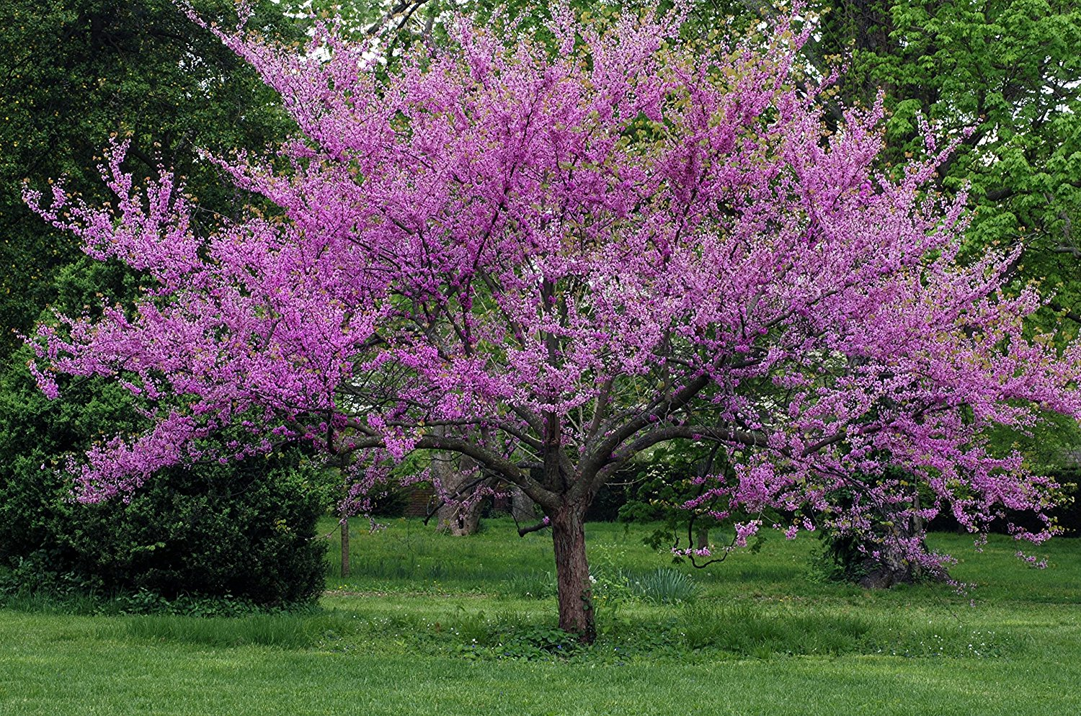  Amelachier canadensis | April -May
Eastern Redbud | Cercis canadensis | April to May
White Fringetree | Chionanthus virginicus | May - June
Flowering Dogwood | Cornus florida | April - May
Cockspur Hawthorn | Crataegus crus-galli | May - June
Southern Hawtorn | Crataegus viridis | April - May
American Holly | Ilex opaca | May - June
Eastern Red Cedar | Juniperus virginiana | March - April
Sweet Bay Magnolia | Magnolia virginiana | May - July
Wild Crabapple | Pyrus coronaria | April - May
Sassafras | Sassafras albidum | April - May
Choke Cherry | Prunus virginiana | May - June

COMMON EVERYDAY NATIVE PLANTS to MARYLAND

Common Name | Botanical Name | Season of Bloom
River Birch | Betula nigra | April to May
Red Maple | Acer rubrum | March to April
Silver Maple | Acer saccharinum | March
Box Elder | Acer negundo | March to April
Common Persimmon | Diospyros virginiana | May to June
White Ash | Fraxinus americana | April to May
Red Ash | Fraxinus pennsylvanica | April to May
Black Walnut | Juglans nigra | May to June
Black Gum | Nyssa sylvatica | May to June
Loblolly Pine | Pinus taeda | Non-flowering
Virginia Pine | Pinus virginiana | Non-flowering
Pitch Pine | Pinus rigida | Non-flowering
White Oak | Quercus alba | May
Swamp White Oak | Quercus bicolor | April
Northern Red Oak | Quercus borealis | May
Scarlet Oak | Quercus coccinea | April to May
Southern Red Oak | Quercus falcata | 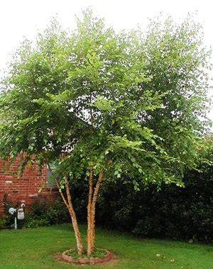  April to May
Pin Oak | Quercus palustris | April
Willow Oak | Quercus phellos | April
Black Locust | Robinia pseudoacacia | May
TALL TREES (>50ft tall)

