Maryland 4-H Animal Science – Rabbit and Cavy
Project Record
Name |  |  | 4-H Age
Primary Club Name
Years in 4-H |  |  | Years in this Project
I have completed this record and believe all information to be complete and accurate.

Member’s Signature Date Parent’s Signature Date

______________________ _________ ______________________ ________
Leader’s Signature Date Educator’s Signature Date

Please indicate your Animal Science Project Area
☐Rabbit (Breeding) | ☐Rabbit (Market) | ☐Cavy
What goals did you set for your project this year and did you achieve them?
1.

2.

3.

What were four things you learned from completing this project this year?
1.

2.

3.

4.

What is one thing you would like to improve or do differently with your project next year?
Life Skills
Describe the Life Skills you used and what you learned in relation to your project.
Example Table
I used one or more of these Life Skills from the Targeting Life Skills Wheel | What I learned as a result of using this skill.
HEAD  Example: Decision Making | I learned that I needed to be sure to budget my money when purchasing my rabbit projects so I would have enough to cover all of my expenses.
HEART  Example: Sharing | I learned how to give younger 4-H members pointers on how to fit and show their animals properly.
HAND  Example: Healthy Life Choices | I learned that animals don’t grow well unless they receive the proper food.
HEALTH  Example: Managing Feelings | I learned to control my feelings when I became frustrated that my pig would not cooperate to get loaded on the trailer

I used one or more of these Life Skills from the Targeting Life Skills Wheel | What I learned as a result of using this skill.
HEAD | 1.  2.
HEART | 1.  2.
HAND | 1.  2.
HEALTH | 1.  2.

The diagram below shows many of the Life Skills learned in 4-H:
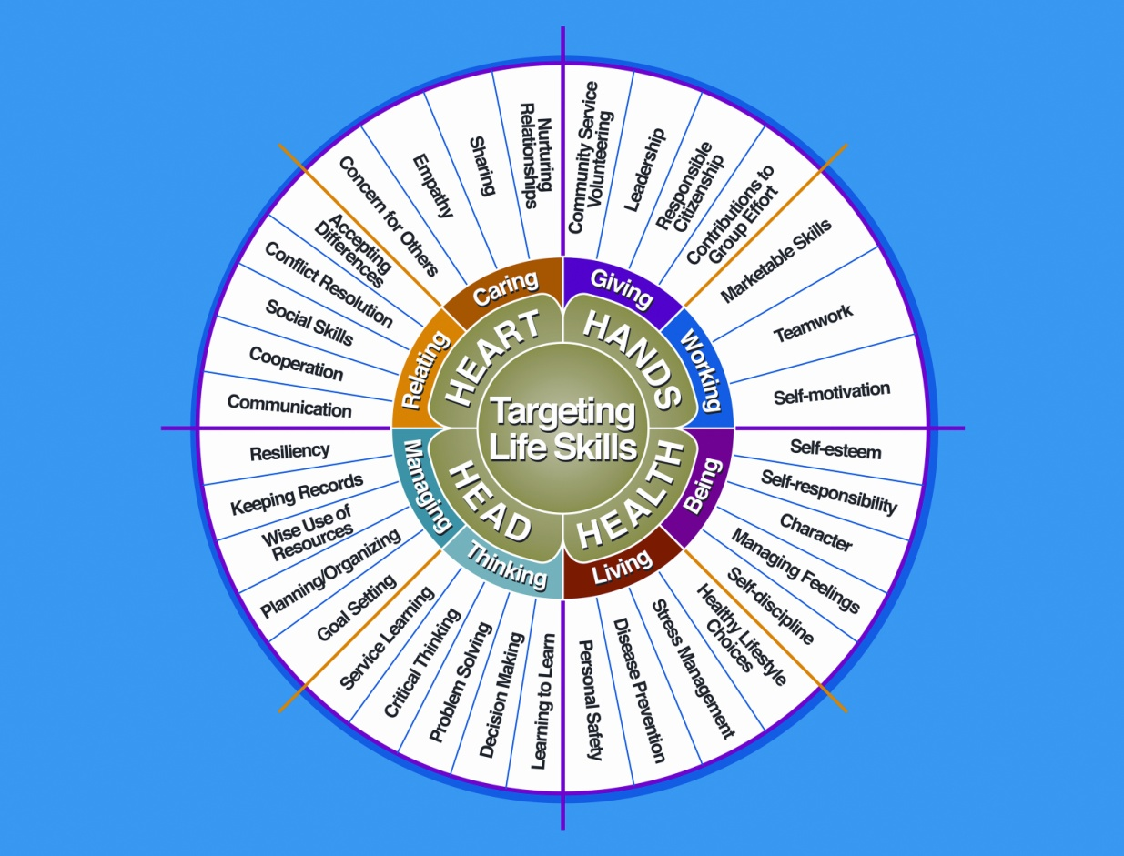

Courtesy of Iowa State University-Used with Permission 11/2012
Project Activities
Include: Field Trips, Skillathon, Judging, Workshops, Quality Assurance, Class Participation, etc.
All project activities listed should be about this project area only.
Date | Name of Activity/Event | Location  (School, Club, County, Regional, State, National etc.)

Project Communications
All project communications listed should be about this project area only.
Date | Type of Communication  (Speech, Demonstration, Visual Presentation, etc.) | Title | Location  (School, Club, County, Regional, State, National etc.)

Project Exhibits
Include: Fairs, Shows, Community Events, etc.
All project exhibits listed should be for projects in this area only.
Date | Exhibit | Location/Event | Placing  (if applicable)

Table 1: Rabbit/Cavy Inventory
(Also include those sold/died)
Animal Name/  Tattoo # | Breed | Sex | Date of Birth | Value or Cost  at Start | Animal Status  (Own, Sold, Died) | Value at End
Total Value

Table 2: Breeding Information
(Only include those who are breeding age)
Name/Tattoo # | Date Gave Birth | Date Bred | Number Born | Number Weaned | Name of Sire/Tattoo #

Table 3: Feed Record and Expenses

Month | Type of Feed | Quantity Feed | Cost
Total Feed Costs

Table 4: Health and Veterinary Record and Expenses

Date(s) | Name/Tattoo # | Reason for Treatment or  Veterinary Visit | Treatment | Cost
Total Health and Veterinary Costs

Table 5: All Other Expenses
(Include: Supplies, Equipment, etc.)
Date | Explanation of Expense | Cost
Total Other Expenses

Table 6: All Income
(Include income from project animals including premiums, sale of animals, etc.)
Date | Description of Income | Income
Total All Other Income

Financial Summary: Please make sure to use the above totals.

Determine how much money you made or lost on your project animals. You can determine your profit (or loss) by:

- Add Income
- Value of Animals on Hand at the End of Project (Table 1) $ ________
- All Income (Table 6) $ ________

Total Income (A) $ ________
- Add Expenses
- Project Animal Costs (Table 1-Value at Start) $ ________
- Feed Expenses (Table 3) $ ________
- Health and Veterinary Expenses (Table 4) $ ________
- All Other Expenses (Table 5) $ ________

Total Expenses (B) $ ________

Subtract B from A to get profit or loss Total $ ________ (profit or loss)
University of Maryland Extension programs are open to all persons and will not discriminate against anyone because of race, age, sex, color, sexual orientation, physical or mental disability, religion, ancestry, or national origin, marital status, genetic information, or political affiliation, or gender identity and expression.

1/2013

