4-H Dog Project

MARYLAND 4-H ANIMAL SCIENCE -
DOG PROJECT RECORD

Name |  | 4-H Age
Primary Club Name
Years in 4-H |  | Years in this Project:
I have completed this record and believe all information to be complete and accurate. (Print and sign/date.)

____________________________ ________________ ___________________________ _______________
Member’s Signature Date Parent’s Signature Date

What goals did you set for your project this year and how did you achieve them?

What were two things you learned from completing this project this year?

What is one thing you would like to improve or do differently with your project next year?

Life Skills
Describe the Life Skills you used and what you learned in relation to your project.

Example Table
I used one or more of these Life Skills from the Targeting Life Skills Wheel | What I learned as a result of using this skill.
HEAD  Example: Decision Making | I learned that I needed to be sure to budget my money when purchasing my rabbit proujects so I would have enough to cover all of my expenses.
HEART  Example: Sharing | I learned how to give younger 4-H members pointers on how to fit and show their animals properly.
HAND  Example: Healthy Life Choices | I learned that animals don’t grow well unless they receive the proper food.
HEALTH  Example: Managing Feelings | I learned to control my feelings when I became frustrated that my pig would not cooperate to get loaded on the trailer.

I used one or more of these Life Skills from the Targeting Life Skills Wheel | What I learned as a result of using this skill.
HEAD

HEART

HAND

HEALTH

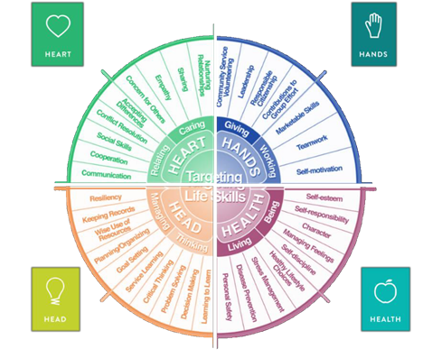

MARYLAND 4-H DOG PROJECT RECORD

Project Activities
Include: Field Trips, Skillathon, Judging, Workshops, Quality Assurance, Class Participation, etc.
All project activities listed should be about this project area only.
Date | Name of Activity/Event | Location  (school, club, county, state, national, etc.)

Project Communications
Include: Speeches, Demonstrations, Visual Presentations, etc.
All project communications listed should be about this project area only.
Date | Type of Communication | Title | Location  (school, club, county, state, national, etc.)

Project Exhibits
Include: Fair, Shows, Community Events, Contests, etc. All project exhibits listed should be for this project area only.
Date | Exhibit/Class | Event/Activity | Placing
Table 1: Dog Information
 | Dog #1 | Dog #2 | Dog #3
Name
Breed
Birthdate
Dog’s Age
Male or Female
Spayed or Neutered
Color
Color of Eyes

Table 2: Write a brief statement about how you obtained your dog
Dog #1
Dog #2
Dog #3

Table 3: Vaccine Record
Dog’s Name | Vaccine | Date Given | Date Due (Expiration)

Table 4: Health and Veterinary Expenses
Dog’s Name | Date | Reason for Treatment or Veterinary Visit | Treatment | Length of Treatment | Cost
Total Health and Veterinary Costs

Table 5: Feeding Record and Expenses
Dog’s Name | Type of Food | Amount Fed/Week | Total Cost per Week | Total Cost/Year  (Total Cost Per Week x 52 Weeks)
Total Costs

Table 6: All Other Expenses
Includes: Leash, Collar, Bedding, Toys, Training, Treats. etc.
Dog’s Name | Date | Explanation of Items | Cost
Total of All Other Expenses

Table 7: All Income
Includes: Premiums, Selling Puppies, etc.
Date | Description of Income | Income
Total Income

Table 8: Training Record
Check commands or exercises that your dog has learned.
 | (Insert Dog’s Name) | (Insert Dog’s Name) | (Insert Dog’s Name)
Heel on Lead
Heel off Lead
Come
Sit
Sit and Stay
Down
Down and Stay
Stand for Examination
Beg
Catch
Carry
Fetch
Roll Over
Jump
Don’t Touch It
Drop on Recall
Other (write in)
Other (write in)

Table 9: Daily Care and Routine
Explain the daily care and routine you follow with your dog.
Dog’s Name | Explanation

Financial Summary: Please make sure to use the above totals.
Determine how much money you made or lost on your project animals. You can determine your profit/loss by:
- Income | - Income Total (Table 7) | $
 | Total Income (A) | $
- Expenses | - Health and Veterinary Expenses (Table 4) | $
 | - Feed Expenses (Table 5) | $
 | - All Other Expenses (Table 6) | $
 | Total Expenses (B) | $
- Total | Subtract B from A to get total | $  (Profit or loss)

