Maryland 4-H Animal Science – Small Pet Project Record
Name |  |  | 4-H Age
Primary Club Name
Years in 4-H |  |  | Years in this Project
I have completed this record and believe all information to be complete and accurate.

Member’s Signature Date Parent’s Signature Date

______________________ ________ _______________________ _________
Leader’s Signature Date Educator’s Signature Date

Please indicate your Small Pet Project(s):
☐Cat | ☐Gerbil | ☐Hamster | ☐Snake | ☐Other ________
What goals did you set for your project this year and did you achieve them?
1.

2.

3.

What were four things you learned from completing this project this year?
1.

2.

3.

4.

What is one thing you would like to improve or do differently with your project next year?
Life Skills
Describe the Life Skills you used and what you learned in relation to your project.
Example Table
I used one or more of these Life Skills from the Targeting Life Skills Wheel | What I learned as a result of using this skill.
HEAD  Example: Decision Making | I learned that I needed to be sure to budget my money when purchasing my rabbit projects so I would have enough to cover all of my expenses.
HEART  Example: Sharing | I learned how to give younger 4-H members pointers on how to fit and show their animals properly.
HAND  Example: Healthy Life Choices | I learned that animals don’t grow well unless they receive the proper food.
HEALTH  Example: Managing Feelings | I learned to control my feelings when I became frustrated that my pig would not cooperate to get loaded on the trailer

I used one or more of these Life Skills from the Targeting Life Skills Wheel | What I learned as a result of using this skill.
HEAD | 1.  2.
HEART | 1.  2.
HAND | 1.  2.
HEALTH | 1.  2.

The diagram below shows many of the Life Skills learned in 4-H:
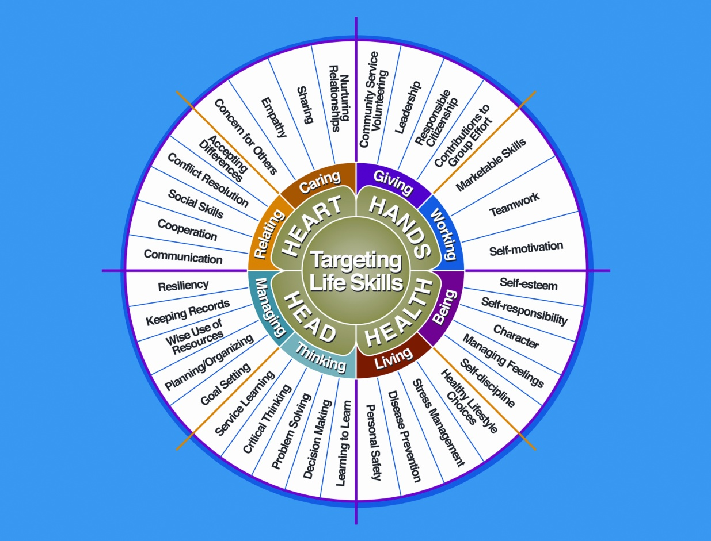

Courtesy of Iowa State University-Used with Permission 11/2012
Date | Name of Activity/Event | Location  (School, Club, County, Regional, State, National etc.)

Project Communications
All project communications listed should be about this project area only.
Date | Type of Communication  (Speech, Demonstration, Visual Presentation, etc.) | Title | Location  (School, Club, County, Regional, State, National etc.)

Project Exhibits
Include: Fairs, Shows, Community Events, etc.
All project exhibits listed should be for projects in this area only.
Date | Exhibit | Location/Event | Placing  (if applicable)

Table 1: Small Pet Information
 | Pet #1 | Pet #2 | Pet#3
Name
Breed
Birthdate
Pet’s Age
Male or Female
Spayed or Neutered
Color

Table 2: Write a brief statement about how you obtained your small pet
Pet #1
Pet #2
Pet #3

Table 3: Vaccine Record

Pet’s Name | Vaccine | Date Given | Date Due (Expiration)

 | Table 4: Health and Veterinary Record and Expenses
Date(s) |  | Pet’s Name | Reason for Treatment or  Veterinary Visit | Treatment | Cost
Total Health and Veterinary Costs

Table 5: Feeding Record and Expenses

Pet’s Name | Type of Food | Amount Fed /Week | Total Cost Per Week | Total Cost/Year  (Total Cost Per Week x 52 Weeks)
Totals

Table 6: All Other Expenses
Includes: Toys, Training, Treats, etc.
Pet’s Name | Date | Explanation of Items | Cost
Total All Other Expenses

Table 7: All Income
Includes: Premiums, Selling Offspring, etc.
Date | Description of Income | Income
Total Income

Table 8: Daily Care and Routine
Explain the daily care and routine you follow with your pet(s)
Pet’s Name | Explanation

Financial Summary: Please make sure to use the above totals.

Determine how much money you made or lost on your project animals.
You can determine your profit (or loss) by:

- Income

- Income Total (Table 7) $ ________

Total Income (A) $ ________

- Add Expenses

- Health and Veterinary Expenses (Table 4) $ ________
- Feed Expenses (Table 5) $ ________
- All Other Expenses (Table 6) $ ________

Total Expenses (B) $ ________

Subtract B from A to get profit or loss Total $________ (profit or loss)

University of Maryland Extension programs are open to all persons and will not discriminate against anyone because of race, age, sex, color, sexual orientation, physical or mental disability, religion, ancestry, or national origin, marital status, genetic information, or political affiliation, or gender identity and expression.
3/2013

