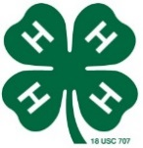
Talbot 4-H Record Book

Click on each field. Then type your information in the box.

This record book belongs to:

4-H program year: 20

Mailing address:

Birth date:

4-H age (as of Jan. 1 of the year this record book is from):

Age category:
(Junior = 8-10, Intermediate = 11-13, Senior = 14-18)

T-Shirt Size: Choose from Youth (YM/YL) or Adult (S/M/L/XL/XXL)

4-H club(s):

Please add a
photo of yourself here
or in your
photographs section

My 4-H goals for the year:

My 4-H projects for the year:

I have reviewed this record book:

Signature ______________________________________ ___________________
4-H Club Leader/Volunteer Date
Comments:

Maryland 4-H Summary Record
(Use the summary record for all 4-H information NOT included in your project records.)

Club Participation
These are meetings I attended (check or make notes)
Club Name | Jan | Feb | Mar | Apr | May | Jun | Jul | Aug | Sep | Oct | Nov | Dec

Committees & Offices (4-H, school, etc.)
Describe how you demonstrated leadership and support in your 4-H club,
the county 4-H program, community service projects, etc.
Name of Committee/Office/Role | Description of What I Did

4-H Promotional Activities
Describe how you promoted or publicized 4-H in these ways during the year
(for example, news articles, TV, radio, 4-H Ambassador responsibilities, displays,
fair booths, flyers, new member recruitment, educational activities, etc.
Date | Activity  Describe the activity and location. | Results  Who did you reach?  What did people learn?
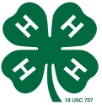

Communication (Public Speaking) Activities NOT Included in Project Records
Describe your public speaking activities that are not included in your 4-H project records.
Examples include public speaking contests, demonstrations and talks not related to your projects, reports given at club meetings, talks at school or community organizations or events, etc.
Date | Description of Communication Activity | Event or Location

Awards and Honors NOT Included in 4-H Project Records
Describe any recognition you have received during the year.
Examples include fair awards, service learning awards, and certificates of appreciation.
Date | Description of Award or Honor | Received From/At

Miscellaneous Activities, Events, and Experiences
In this section you may share any important 4-H and non-4-H activities, events, and learning experiences that are not included in other parts of your record book. Examples include 4-H club field trips, school service learning projects, after school activities, volunteer work, etc.
Date | Description of Activity or Event | Location
(You may add other pages as needed)

What Should I Write About in My 4-H Story?
- Introduction: Your name, age, family information, where you go to school, your interests, when and why you joined 4-H, etc. (Is someone helping you write or type your story?)
- Your Projects: What are they? How 4-H has helped you learn new things about your projects? What kinds of things have you learned? Intermediates and Seniors: Please include at least one paragraph for each completed project you submit. Please DO NOT write separate 4-H stories for each project!
- Other 4-H Activities: Include major learning experiences, special interests and other situation(s). Include your club activities, community service projects, county level activities, other activities, and what you learned or accomplished during the year.
- Life Skills Learned: Include a description of how the Head, Heart, Hands, and Health related to your 4-H 4-H experiences during the past year. For example, explain what you learned (head), how you helped others (heart), what skills you developed and what projects you completed (hands), and how 4-H helped you gain leadership skills, help others, or reach your goals (health). You might want to tell about your future plans and career plans. Note: The project record has a section where you can describe life skills learned as a result of a specific project. You do NOT need to describe all of your project skills in your 4-H story.

You may get help with typing or handwriting your story, but your story needs to be in YOUR own words. Just tell us about your past year’s 4-H experiences: what you did and learned!

My 4-H Story for the Year 20

Please enter a one-sentence quotation about your experience in 4-H this year. We will print it and put it on a table card at the Achievement Program.

Click on the box below and begin typing your 4-H story. The box will expand as you type.

General 4-H Project Record #1
(For each project you worked on, fill out a record if you
would like formal recognition of your project work.)

Click on each field. Then type your information in the box.

To complete a project and qualify for an award pin, you need to do the following things:
(1) learning experiences: participate in several learning experiences that help you learn about the project;
(2) communication event: give a talk or presentation that is related to your project;
(3) exhibit: display your project-related work somewhere in a public place.
Completion of two out of three requirements qualifies you for a project certificate.

Name:

4-H Age:

Name of Project:

Number of years I have worked on this project:

Title of 4-H Project Guide (if you used one):

These were my project goals for the year:
I have completed this record and I believe that all information is complete and accurate.

Member Signature Date

Parent Signature Date

Date | Communication Events  Describe the talks and presentations you have given about this project. | Location | Rating/How did you do?

Date | Exhibits  Describe the public displays, posters, fair entries, and awards related to this project. | Location | Rating/How did you do?

Date | Learning Experiences  Describe the things you have done to learn more about this project: meetings, tours, workshops, club activities, research, etc. | What I Learned
Need more room? Add a page if necessary.
Date | Financial Journal  Income is the money you have received from fair premiums, selling items, etc. for this project. Expenses are the money you have spent related to this project. | Income | Expenses
 |  | Income:
 |  | Expenses:
 |  | Profit (+) or Loss (-):

Resources
You may want to use this space to list or describe the resources you used to learn more about this project. Include books, internet sites, volunteers, parents, other 4-H members, and professionals.

Project Skills
Did you accomplish your project goals this year? Why or why not?

What are the most important things you have learned from this project and/or what are the most important results of your work on this project?

Life Skills

Fill out this section to describe the life skills you used and what you learned in relation to your project. Examples
I used these Life Skills | This is what I learned as a result of using this skill
HEAD  Example: Decision Making | I learned that I needed to be sure to budget my money when purchasing craft supplies so I would  have enough to cover all of my expenses.
HEART  Example: Sharing | I learned how to give younger 4-H members pointers on how to make a wreath through a visual  presentation.
HAND  Example: Community Service Volunteering | Through my woodworking project, I have learned many new skills. I found it to be beneficial to  my community to utilize those woodworking skills when volunteering to build a wheel chair ramp.
HEALTH  Example: Managing Feelings | I learned to control my feelings when I became frustrated that the new cake I baked didn’t rise. Since I didn’t have success with the new cake recipe, I am going to research other options that I could try.

I used these Life Skills This is what I learned as a result of using this skill.
(see the Life Skills Wheel for ideas)
- HEAD :
- HEART:
- HANDS :
- HEALTH :

Life Skills Wheel: The diagram below shows many of the life skills learned in 4-H.
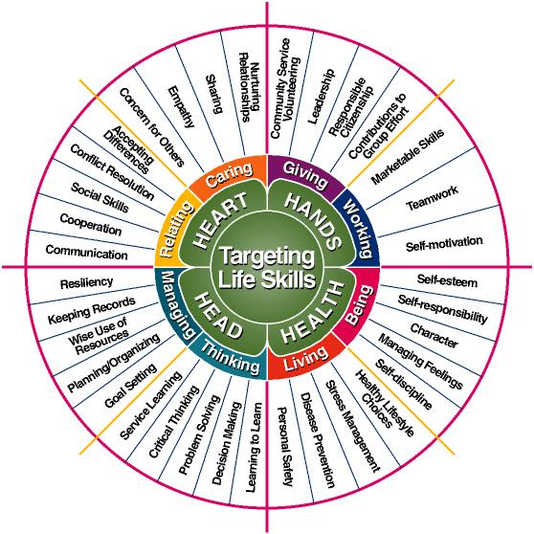
Courtesy of Iowa State University
General 4-H Project Record #2
(For each project you worked on, fill out a record if you
would like formal recognition of your project work.)

Click on each field. Then type your information in the box.

To complete a project and qualify for an award pin, you need to do the following things:
(1) learning experiences: participate in several learning experiences that help you learn about the project;
(2) communication event: give a talk or presentation that is related to your project;
(3) exhibit: display your project-related work somewhere in a public place.
Completion of two out of three requirements qualifies you for a project certificate.

Name:

4-H Age:

Name of Project:

Number of years I have worked on this project:

Title of 4-H Project Guide (if you used one):

These were my project goals for the year:
I have completed this record and I believe that all information is complete and accurate.

Member Signature Date

Parent Signature Date

Date | Communication Events  Describe the talks and presentations you have given about this project. | Location | Rating/How did you do?

Date | Exhibits  Describe the public displays, posters, fair entries, and awards related to this project. | Location | Rating/How did you do?

Date | Learning Experiences  Describe the things you have done to learn more about this project: meetings, tours, workshops, club activities, research, etc. | What I Learned
Need more room? Add a page if necessary.
Date | Financial Journal  Income is the money you have received from fair premiums, selling items, etc. for this project. Expenses are the money you have spent related to this project. | Income | Expenses
 |  | Income:
 |  | Expenses:
 |  | Profit (+) or Loss (-):

Resources
You may want to use this space to list or describe the resources you used to learn more about this project. Include books, internet sites, volunteers, parents, other 4-H members, and professionals.

Project Skills
Did you accomplish your project goals this year? Why or why not?

What are the most important things you have learned from this project and/or what are the most important results of your work on this project?

Life Skills

Fill out this section to describe the life skills you used and what you learned in relation to your project. Examples
I used these Life Skills | This is what I learned as a result of using this skill
HEAD  Example: Decision Making | I learned that I needed to be sure to budget my money when purchasing craft supplies so I would  have enough to cover all of my expenses.
HEART  Example: Sharing | I learned how to give younger 4-H members pointers on how to make a wreath through a visual  presentation.
HAND  Example: Community Service Volunteering | Through my woodworking project, I have learned many new skills. I found it to be beneficial to  my community to utilize those woodworking skills when volunteering to build a wheel chair ramp.
HEALTH  Example: Managing Feelings | I learned to control my feelings when I became frustrated that the new cake I baked didn’t rise. Since I didn’t have success with the new cake recipe, I am going to research other options that I could try.

I used these Life Skills This is what I learned as a result of using this skill.
(see the Life Skills Wheel for ideas)
- HEAD :
- HEART:
- HANDS :
- HEALTH :

Life Skills Wheel: The diagram below shows many of the life skills learned in 4-H.
Courtesy of Iowa State University

Attach these final three sections and your record book will be complete!

*My 4-H Photographs
(In this section, include photos of your 4-H experiences. Be sure to include a caption for each photo.)

*My 4-H News (and Other) Clippings
(In this section, include examples of 4-H in the news. The best examples are articles that show your involvement in 4-H activities. Include date and source of each clipping and highlight important information.)

*My 4-H Correspondence
(In this section, include examples of newsletters, letters, thank you notes, certificates, and other documents you have received that relate to 4-H experiences and projects.)

