Calculation of Slope Length, Percent Slope, and Distance to Water for PMT
Updated January 2020

Double click on the table below to edit it like an Excel spreadsheet. Please enter the required information in the white boxes.
Supporting Information and Maps
Please provide supporting documentation for the calculations in the table above.
- The distance from the edge of the field to the nearest surface water downhill from the field. Be sure to measure distance in feet
- Up to 3 slope calculations of the dominant runoff/erosion generating portion(s) of the field
  - Measure distance (in feet) from the high elevation to the low elevation in the direction water would flow, towards the nearest surface water.
  - Begin measurement where slope begins
  - End measurement where deposition occurs (indicated by slope leveling out), concentrated flow begins (indicating by U or V shapes in contours pointing upslope), or edge of field is reached.
  - For RUSLE2 calculations, use a maximum slope length of 400 ft.
Below are examples of screenshots taken from QGIS that should be replaced with screenshots from the operation you are working on.
Distance to Water
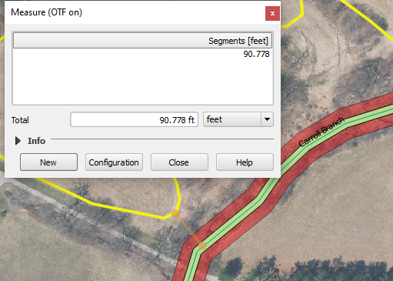

Slope 1
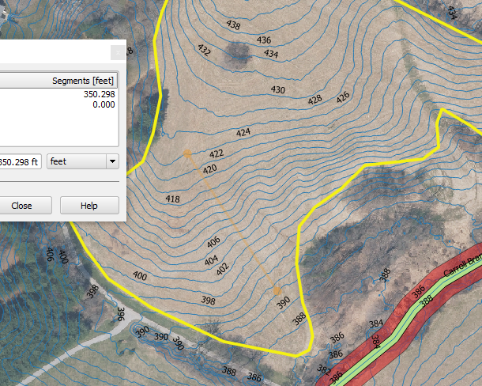
Slope 2
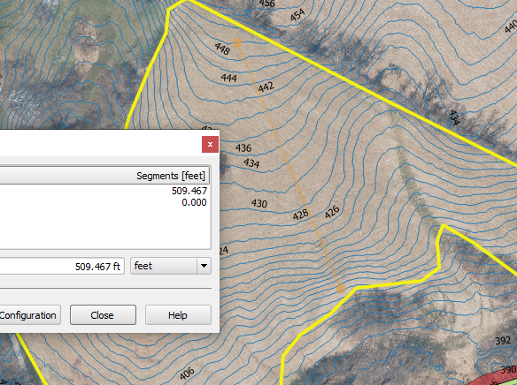

Slope 3
